MINISTRY OF HIGHER EDUCATION AND SCIENCE OF THE REPUBLIC OF KAZAKHSTAN

INTERNATIONAL INFORMATION TECHNOLOGY UNIVERSITY

FACULTY OF BUSINESS, MEDIA AND MANAGEMENT

Bakhytuly N.
Sarsenbek A. B.
Temirov D. D.

Development of an AI-Powered Virtual Character

DIPLOMA PROJECT

Major 6B06105 – Information Systems

Almaty 2024

MINISTRY OF HIGHER EDUCATION AND SCIENCE OF THE REPUBLIC OF KAZAKHSTAN

INTERNATIONAL INFORMATION TECHNOLOGY UNIVERSITY

DEPARTMENT OF INFORMATION SYSTEMS

Approved
Head of Information Systems
Department,
Doctor of Technical Science, Professor
___________Naizabayeva L.
«___»____________________2024

DIPLOMA WORK

Development of an AI-Powered Virtual Character

Major 6В06105 – Information Systems

Done by: | Bakhytuly N.  «___» ______2024 | ___________________  (signature)
 | Sarsenbek A.B.  «___» ______2024 | ___________________  (signature)
 | Temirov D.D.  «___» ______2024 | ___________________  (signature)
Research Supervisor: | Myrzakerimova A.B.  «___» ______2024 | ___________________  (signature)
Reviewer: | Kartbayev A.ZH.  «___» ______2024 | ___________________  (signature)

Almaty 2024

International Information Technology University
Faculty of Business, Media and Management
Department of Information Systems
Major 6В06105 – Information Systems

Diploma Work/Project Assignment

Students
Bakhytuly N., Sarsenbek A.B., Temirov D.D.

Diploma Work/Project Topic
Development of an AI-Powered Virtual Character

Approved by IITU order № ___ dated «___» ______ 2024

Diploma Work/Project submission date «___» ______ 2024

Diploma Work/Project initial data

Details of computations and explanations (list of issues due to be addressed)

CD containing the digital version of Diploma Work/Project and attachments

Consultations on Diploma Work/Project (with related Work/Project chapters named)

Consultant | Name | Signature, date
Consultant | Name | Assignment given | Assignment received
Consultant on
Economic
Effectiveness of
the Diploma Work/Project
English
Language
Consultant
Compliance
Monitor

Date «___» ______ 2024

Research Supervisor | ___________________  (signature)
Assignment received by | ___________________  (signature)

Diploma Work/Project writing schedule

Bakhytuly N., Sarsenbek B.A., Temirov D.D.

Title: Development of an AI-Powered Virtual Character

№ | Assignment | Submission date
 | Creation of the Diploma Work/Project writing schedule | November 30
 | Collection, study, processing, analyzing, and generalizing data | November – December
 | Drafting and submission to the Research Supervisor (Introduction, Chapter 1, Chapter 2, Chapter 3, Chapter 4, Conclusion) | January – February
 | Submission of the chapter «Economic effectiveness of the Diploma Work/Project» to the consultant | March – April
 | Revision of the Diploma Work/Project with due consideration of the Research Supevisor’s comments | March – April
 | Submission of the completed Diploma Work/Project to the Research Supervisor | April 15
 | Pre-defence | April
 | Submission of the completed Diploma Work/Project to the English Language Consultant | April 20 – April 30
 | Submission of the Diploma Work/Project to the Compliance Monitor | April 30 – May 15
 | Submission of the Diploma Work/Project for the plagiarism | May 2 – May 20
 | Submission to the Reviewer for approval | May 3 – May 31
 | Diploma Work/Project defense | June 3 – June 20

Student: | Bakhytuly N. | ___________________  (signature)
Student: | Sarsenbek A.B. | ___________________  (signature)
Student: | Temirov D.D. | ___________________  (signature)
Research Supervisor: | Myrzakerimova A.B. | ___________________  (signature)
Date «___» ______ 2024

АҢДАТПА

Бұл дипломдық жұмыс жасанды интеллектпен басқарылатын дауыстық командаларды пайдалана отырып, пайдаланушыларға виртуалды кейіпкермен әрекеттесуге мүмкіндік беретін веб-сайт пен қолданбаны әзірлеуге бағытталған. Веб-сайт қолданбаны көрсету және қолдау үшін негізгі құрал ретінде қызмет етеді. Жоба нақты талдауды, функционалдық талаптарды, әзірлеу процестерін, сауалнамалар арқылы пайдаланушының кері байланысын және қолданбаның экономикалық өміршеңдігін бағалауды қамтиды.
Кіріспе жасанды интеллект негізіндегі виртуалды кейіпкерлердің өзектілігін негіздейді және олардың әртүрлі салалардағы әлеуетін көрсетеді. Әдебиеттерге шолу қазіргі технологиялар мен платформаларға жан-жақты талдау жасайды. Ол сондай-ақ олқылықтар мен инновация мүмкіндіктерін анықтайтын салыстырмалы талдауды қамтамасыз ете отырып, Қазақстандағы ұқсас қолданбаларды зерттейді. Дизайн және әзірлеу бөлімі пайдаланушыға ыңғайлы мүмкіндіктер мен кеңейтілген жасанды интеллект мүмкіндіктерін қамтитын веб-сайт пен қолданба дизайнын нақты көрсетеді. Сауалнама деректері пайдаланушылардың виртуалды аватармен қалай әрекеттесетіні туралы құнды түсініктер береді, бұл болашақ жақсартуларды басқаруға көмектеседі. Экономикалық талдау жобаның экономикалық орындылығын көрсете отырып, нарықтық әлеуетті және табыстылығын бағалайды.
Дипломдық жұмыс 46 сурет, 6 кесте, 40 әдебиет көзі және 74 бет мәтінмен қоса берілген, жобаның дамуы мен оның практикалық қолданылуының толық көрінісін береді.
Түйін сөздер: ҚОЛДАНБАЛАРДЫ ӘЗІРЛЕУ, ЖАСАНДЫ ИНТЕЛЛЕКТ, ДАУЫСПЕН ӘРЕКЕТТЕСУ, ВИРТУАЛДЫ КЕЙІПКЕР, ВЕБ-САЙТТЫ ЖАРНАМАЛАУ, ДАМУ ТРАЕКТОРИЯСЫ, ЭКОНОМИКАЛЫҚ ӨМІРШЕҢДІК.

АННОТАЦИЯ

Данная дипломная работа посвящена разработке веб-сайта и приложения, позволяющего пользователям взаимодействовать с виртуальным персонажем с помощью голосовых команд, управляемых искусственным интеллектом. Веб-сайт служит ключевым инструментом для представления и поддержки приложения. Проект включает в себя подробный анализ, функциональные требования, процессы разработки, обратную связь с пользователями через опросы и оценку экономической жизнеспособности приложения.
Во введении обосновывается актуальность виртуальных персонажей на основе ИИ, подчеркивается их потенциал в различных областях. В обзоре литературы представлен всесторонний анализ современных технологий и платформ. В нем также рассматриваются аналогичные приложения в Казахстане, проводится сравнительный анализ, выявляющий пробелы и возможности для инноваций. В разделе «Дизайн и разработка» подробно описывается дизайн веб-сайта и приложения, включающий удобные для пользователя функции и расширенные возможности искусственного интеллекта. Данные опроса дают ценные сведения о взаимодействии пользователей с виртуальным персонажем, что позволяет определить направления будущих улучшений. Экономический анализ оценивает рыночный потенциал и рентабельность проекта, демонстрируя его экономическую целесообразность.
Дипломная работа сопровождается 46 рисунками, 6 таблицами, 40 источниками литературы и 74 страницами текста дающими полное представление о развитии проекта и его практическом применении.
Ключевые слова: РАЗРАБОТКА ПРИЛОЖЕНИЙ, ИСКУССТВЕННЫЙ ИНТЕЛЛЕКТ, ГОЛОСОВОЕ ВЗАИМОДЕЙСТВИЕ, ВИРТУАЛЬНЫЙ ПЕРСОНАЖ, ПРОДВИЖЕНИЕ ВЕБ-САЙТА, ТРАЕКТОРИЯ РАЗВИТИЯ, ЭКОНОМИЧЕСКАЯ ЖИЗНЕСПОСОБНОСТЬ.

ABSTRACT

This diploma work covers the development of a website and an application that allows users to interact with a virtual character using voice commands, powered by artificial intelligence. The website serves as a key tool for introducing and supporting the application. The project includes detailed analyses, functional requirements, development processes, user feedback through surveys, and an assessment of the application's economic viability.
The introduction establishes the relevance of AI-powered virtual characters, highlighting their potential across various domains. The literature review provides a comprehensive analysis of current technologies and platforms. It also examines similar applications in Kazakhstan, offering a comparative analysis that identifies gaps and opportunities for innovation. Design and Development section details the design of both the website and the application, incorporating user-friendly features and advanced AI capabilities. The survey data provides valuable insights into user interactions with the virtual character, guiding future improvements. The economic analysis assesses the project's market potential and profitability, demonstrating its economic viability.
The diploma work is supported by 46 figures, 6 tables, 40 sources of literature and 74 pages of text providing a comprehensive overview of the project’s development and its practical applications.
Keywords: APPLICATION DEVELOPMENT, ARTIFICIAL INTELLIGENCE, VOICE INTERACTION, VIRTUAL CHARACTER, WEBSITE PROMOTION, DEVELOPMENTAL TRAJECTORY, ECONOMIC VIABILITY.

CONTENTS

List of terms and abbreviations 10
INTRODUCTION 11
1 ANALYSIS OF THE APPLICATION OF AI-BASED VIRTUAL CHARACTER 12
1.1 Process of creating a virtual character 12
1.2 Justification of the need and goals of using VC based on AI 12
1.3 Literature review 13
1.3.1 Analysis of existing analogues 13
1.3.2 Analysis of analogues in Kazakhstan 20
1.3.3 Comparative analysis of existing analogues 22
1.4 Analysis of virtual character and web-site development tools 24
2 DESIGNING THE WEBSITE AND APPLICATION
FOR VIRTUAL CHARACTERS BASED ON AI 32
2.1 Functional requirements 32
2.1.1 Functional Requirements for the Website 33
2.1.2 Functional requirements for application 33
2.2 Design Techniques 34
2.2.1 Defining Use Cases 34
2.2.2 Designing ER-Diagram 36
2.2.3 Drawing UML-Diagram 37
2.2.4 Defining service architecture 39
3 DEVELOPMENT OF A WEBSITE AND APPLICATION
FOR VIRTUAL CHARACTERS BASED ON AI 41
3.1 Desktop development 41
3.2 Web development 52
3.2.1 Website Architecture 52
3.2.2 Client-side development 54
3.2.3 Interaction with the server 58
4 RESULTS OF THE EXPERIMENT 60
4.1 Aim of experiment 60
4.2 User survey about interaction with a virtual character 60
5 JUSTIFICATION OF ECONOMIC EFFICIENCY 67
5.1 Technical description 67
5.2 Marketing analysis 67
5.3 Marketing plan 68
5.4 Calculation of economic efficiency 68
5.5 Calculation of the effectiveness of software implementation
for an enterprise 72
CONCLUSION 74
REFERENCES 75
APPENDIX 77
List of terms and abbreviations

AJAX – Asynchronous JavaScript and XML
API – Application Programming Interface
AI – Artificial Intelligence
CLI – Command Line Interface
CSS – Cascading Style Sheets
CMS – Content Management System
CRUD – Create, Read, Update, Delete
DI – Dependency Injection
DOM – Document Object Model
ER – Entity Relationship
GUI – Graphical User Interface
HTML – Hyper Text Markup Language
HTTP – Hypertext Transfer Protocol
HTTPS – Hypertext Transfer Protocol Secure
IDE – Integrated Development Environment
JSON – JavaScript Object Notation
JS – JavaScript
JWT – JSON Web Token
MVC – Model View Controller
MVP – Model View Presenter
NPM – Node Package Manager
OOP – Object-Oriented Programming
REST – Representational State Transfer
RDBMS - Relational Database Management System
SDK – Software Development Kit
SPA – Single Page Application
SQL – Structured Query Language
UI – User Interface
UML – Unified Modeling Language
URL – Uniform Resource Locator
UX – User Experience
VCS – Version Control System
VC – Virtual Character
XAML – eXtensible Application Markup Language
XML – eXtensible Markup Language
XPath – XML Path Language

INTRODUCTION

The worlds of entertainment and technology are constantly changing. One of the most exciting developments has been the use of artificial intelligence (AI) to create virtual characters. These characters are more than just part of a game or app and they are becoming a big part of our digital lives, changing how we use technology every day. With growing interest in AI-driven characters, the way we make them is changing. In the past, digital characters were based on fixed scripts, which made them predictable. But now, thanks to AI, these characters can learn from interactions and respond in real time, making each interaction unique and much more engaging.
The progress in AI has allowed these characters to behave in ways that seem very human-like. They can be used in various settings, including video games, educational software, and customer service, thanks to their ability to process natural language and recognize emotional cues. However, creating these advanced characters isn’t easy. The tools available today are often too specialized and not very user-friendly. We need a better, more integrated tool that makes creating and managing these characters simpler. This is why developing a comprehensive platform for AI-powered virtual characters is crucial. This platform would offer powerful, easy-to-use tools for creators to manage virtual characters suited for different industries. It would include advanced AI features, intuitive design interfaces, and detailed analytics to improve character creation and deployment. This new platform could revolutionize how we interact with digital characters across various sectors like storytelling, education, and customer service, making it easier for more people to innovate and create with AI.
The significance of this project extends beyond creating efficient tools for developers. It represents a shift in how we envision digital engagement, fostering creativity and enhancing the quality of interactions between people and technology. By offering a more intuitive and accessible way to build AI-powered virtual characters, this platform will play a key role in unlocking new opportunities across many industries.
Object: the process of creating digital characters.
Subject: developing a platform for AI-powered virtual characters.
Goal: build a comprehensive platform that includes a website and a desktop application. This platform will enable the creation and interaction with AI-powered characters through voice communication.
To achieve this goal, we must do the following:
1. Study the current technology and applications of AI-powered virtual
characters.
2. Evaluate existing platforms and tools to identify where improvements can be made.
3. Design a platform that is easy to use and equipped with the latest AI tools.
4. Build and launch the platform to support the creation and management of versatile AI-powered virtual characters for various applications.

1 ANALYSIS OF THE APPLICATION OF AI-BASED VIRTUAL CHARACTER

1.1 Process of creating a virtual character

AI is transforming many aspects of life, even if not everyone is familiar with it. It is a wide-ranging tool that enables people to rethink how we integrate information, analyze data, and use the resulting insights to improve decision-making [1].
Building virtual characters is a multidisciplinary task, requiring various technical solutions. Nowadays, existing tools and frameworks make character creation easier. First, it's crucial to outline the desired outcome of the product. Next, the development process should be broken down into different stages.
In the first stage, the main job is to identify the key features of the future product, such as setting goals and defining how users will interact with it. This step helps plan the initial design and lays the foundation for the next steps. In the second stage, the focus shifts to creating the character virtually, possibly by using existing solutions through special software to give users a virtual experience. Here, the character will be brought to life with artificial intelligence. In the third stage, the artificial intelligence and needed data sets are reviewed. We don't need to build AI from scratch because we can use publicly available models. Instead, the goal is to make an app that works well with these technologies. In the fourth stage, we integrate the AI into the platform, specifically an app for Windows. Next, we conduct thorough testing with a target user group to fix any bugs or mistakes. The final step is to officially launch the product and collect user feedback to keep improving it.
It's important to highlight the value of user-focused design in creating virtual characters. Software should be built with "no tricks" and "honesty," as ethics experts advise. When failures occur, there must be mitigation mechanisms to deal with the consequences [2]. This ensures the final product not only meets technical standards but also connects with users both practically and emotionally. Ethical matters are also crucial, especially concerning data privacy and how AI might affect interactions. Lastly, this development process should constantly be evaluated and adjusted, using user feedback and new technology to make the virtual character more relevant and effective. This broad view on development emphasizes both technical and bigger-picture aspects of virtual characters in different fields.

1.2 Justification of the need and goals of using VC based on AI

Artificial intelligence-based virtual characters offer many benefits, making them popular in different fields. They have various uses, like helping with education by creating specialized lessons and drawing attention in the entertainment industry. Technology has enough to make things like chatbots, and online learning platforms. Duolingo application is an application that is supported by artificial intelligence [3]. AI-based virtual characters also demonstrate potential in technical support.
Virtual characters improve the user experience by providing a unique, interactive platform that significantly boosts user involvement and satisfaction. This innovative approach to education lets students interact with artificial intelligence, a technology crucial to the future of humanity. The idea is to use AI to help teachers deliver lessons through virtual characters, making the learning experience better. In education, virtual characters are powerful tools for personalized learning. They can present material tailored to each student's needs, helping address learning gaps and develop better strategies using detailed student data analysis. Virtual characters can also work as chatbots, meeting people's basic need to communicate, which isn't always easy. By talking with a virtual character, people can share their concerns and receive useful advice or solutions. But it's important to recognize the limitations of chatbots since they don't have personal experiences or needs and can't share stories or predict user needs. A chatbot has no real experiences or needs, it cannot truthfully communicate its own experiences, and it may not expect the user to tend to its needs [4]. Despite these limits, the adaptability of AI helps virtual characters grow beyond just communication tools and even become genuine virtual companions.
The rise of AI-powered virtual characters marks a major shift that will change many aspects of society and how things work. By using AI technology, these virtual beings are leading a transformation in traditional processes, providing advanced solutions that improve human interaction and enable custom services in many fields. While this technology continues to develop, it promises a digital ecosystem that's more adaptable, effective, and inclusive. But it's crucial to implement it thoughtfully and ethically.

1.3 Literature review
Literature review is an integral part of any research study, as it helps to systematize the existing knowledge on the topic under study, identify the most significant works in the field and identify gaps in the current state of knowledge. The main objective of this section is not only to provide a review of relevant literature, but also to establish a link between the existing data and the goals of the current project, emphasizing the need for further research. The literature review begins by analyzing the historical context of the topic, moving on to an overview of current research and projects. This allows not only to trace the evolution of approaches and methodologies, but also to assess how changes in technology and theoretical frameworks have influenced the current state of scientific knowledge.

1.3.1 Analysis of existing analogues

Before developing an app and website for Virtual Characters, it's crucial to carefully review existing solutions in this field. This involves a detailed comparison of platforms and websites that have similar features to the planned virtual character interface. The main goal of this analysis is to learn about what potential users want and need, which will help guide the design and development strategy.
By closely analysis similar platforms, we can identify key features that will be essential for the success of our website and app. This review also helps understand how users interact with similar platforms, uncovering common issues that users might face. With this information, we can create a platform that meets the specific needs of their target audience while also improving the overall user experience.
The upcoming analysis will include a review of several leading virtual character apps, such as Ask AI, AI Chatbot - Nova, Digital Mate, and Botify AI. Each of these apps has unique features designed for different event types and user preferences. By thoroughly examining these apps, developers will gain valuable insights into the current world of virtual character platforms and identify ways to innovate and improve.
«Ask AI»
The mobile app "Ask AI - Chat with Chatbot," made by Codeway Dijital, offers an advanced platform to interact with artificial intelligence, using technologies like ChatGPT and GPT-4. The app allows users to do many creative and educational activities, like writing stories, poems, song lyrics, and scripts, as well as learning languages and translating text (figure 1.1).

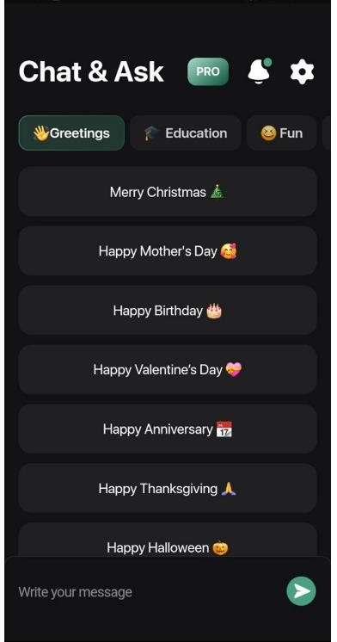
Figure 1.1 – Main page of «Ask AI»

The "Ask AI" app has achieved great success, with over 10 million downloads and an impressive 4.6-star rating from more than 676,000 reviews on the Play Market. These numbers show that the app is widely accepted and seen as useful and effective by its users. It also includes in-app purchases, letting users access extra features and content to improve their experience (figure 1.2).
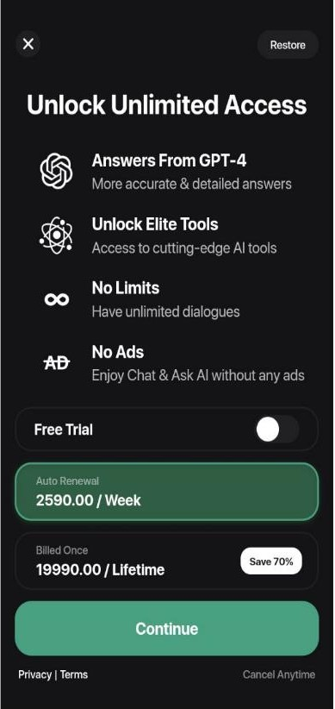
Figure 1.2 – In-app purchases on «Ask AI»

With a modern and easy-to-use design, "Ask AI" provides clear advice on many topics, including ways to earn a good income online. This shows how the app can be a helpful resource for advice in different fields, like business and finance (figure 1.3).

Figure 1.3 – Receiving advice in the financial sector on «Ask AI»
From its description, it's clear that "Ask AI" aims to go beyond basic information sharing, positioning itself as a strong tool for creative projects, learning, and professional communication. This app is especially useful for writers, teachers, students, and professionals who want new ways to enhance their creative work or teaching methods.
Using AI in apps like this is a big step forward for communication and learning technology. It helps users expand their knowledge and make the best use of their time on mobile devices, showing how AI can change traditional approaches to creativity, learning, and professional growth.
«AI Chatbot - Nova»
The "AI Chatbot - Nova" app, created by ScaleUp, is an innovative AI chatbot and personal assistant powered by ChatGPT, GPT-4, and Palm M.2 technologies. Nova helps users find quick answers, discover new ideas, and learn more, making it a great tool for education and research (figure 1.4).

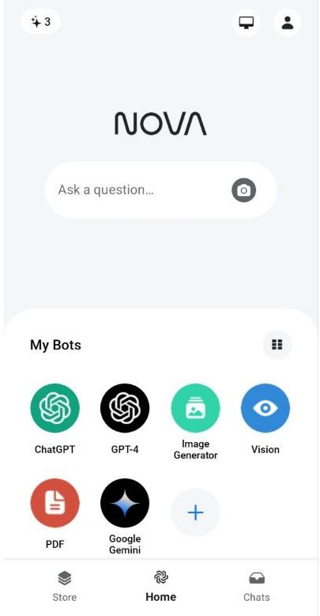
Figure 1.4 – Main page of «AI Chatbot - Nova»

Focused on learning and answering various questions, the app can generate images, chat with an AI assistant, and even shorten long texts, which is helpful for summaries and understanding content. With over 10 million downloads and an average 4.3-star rating from 860,000 reviews, Nova is popular among users. It also includes in- app purchases for extra features and content to improve the user experience (figure 1.5).
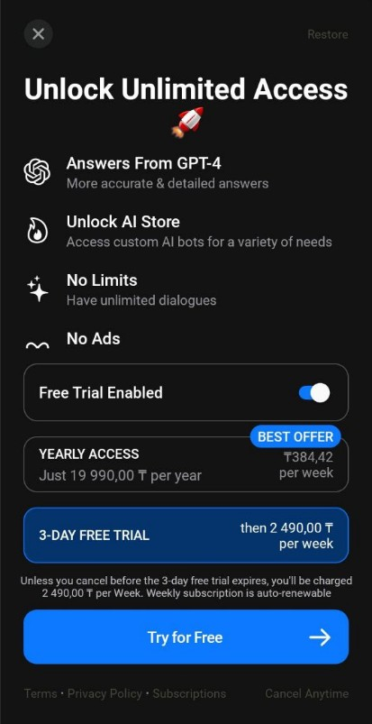
Figure 1.5 – In-app purchases on «AI Chatbot - Nova»

Nova has a clean, easy-to-use design that makes using its features intuitive. Nova Al Chatbot combines advanced Al with user-friendly design, offering a versatile and secure conversational tool [5]. It's highly adaptable, providing solutions for creative, educational, professional, and personal tasks (figure 1.6).

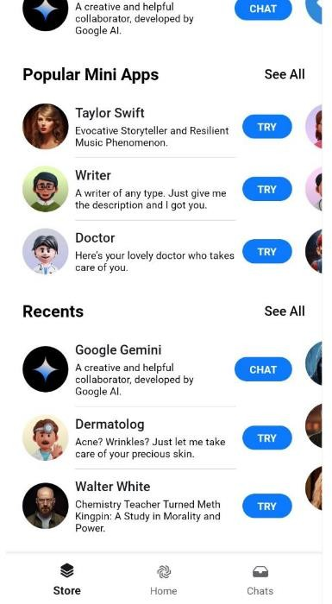
Figure 1.6 – Store page on «AI Chatbot - Nova»
The app shows how AI can create and visualize answers to requests like making a resume cover, drawing pictures, or summarizing a book. This can be helpful for people who need quick information and creative solutions.
By recommending books and movies based on a user's interests, Nova makes the interaction both helpful and fun. This makes it appealing to a wide audience, like students, writers, researchers, and anyone looking for new ways to use technology.
«Digital Mate»
Digital Mate is an app that gives users an exclusive companion on their computer desktop. It’s designed to be part of everyday life by offering interactive entertainment and reminding users of important events. The app has a simple interface (figure 1.7).

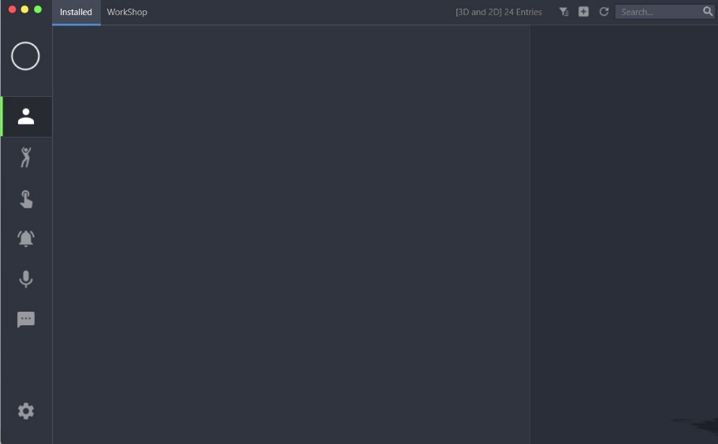
Figure 1.7– Main page on «Digital Mate»

The software combines a virtual desktop companion with interactive reminders and allows physical interaction through a touch-based interface. It's efficient because of its lightweight rendering engine, which reduces the strain on system resources and ensures good compatibility with other apps and dynamic wallpapers, making the software easier to use.
Despite mostly positive feedback, there's a noticeable difference between recent and overall reviews, hinting at potential areas for improvement, particularly with stability and features in the latest updates (figure 1.8).
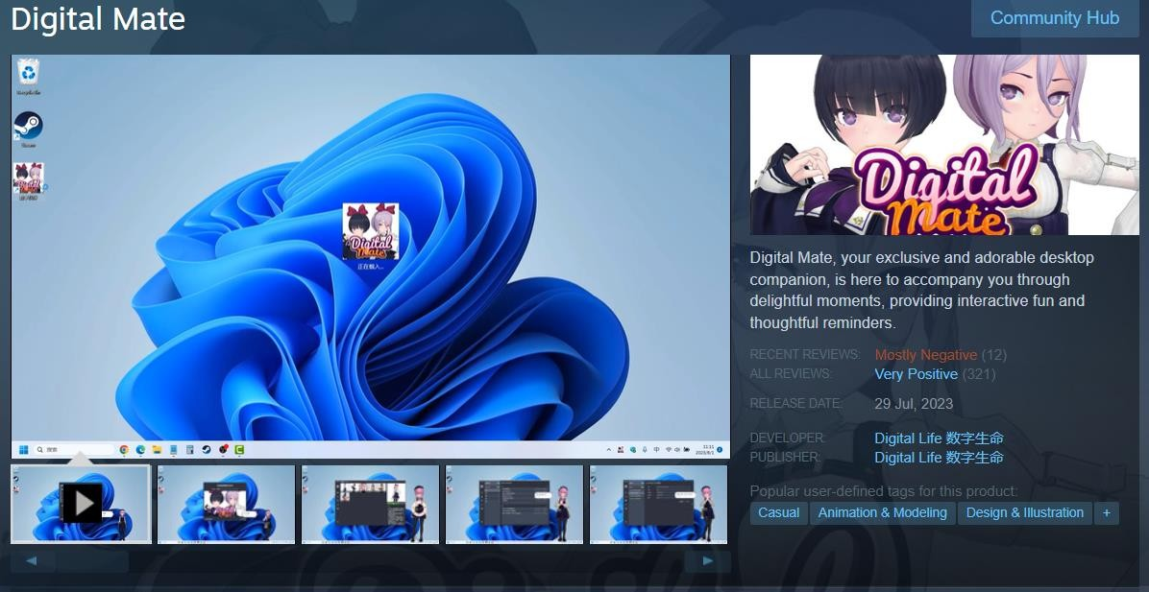
Figure 1.8– Digital Mate store page on «Steam»
«Botify AI»
Botify AI is an innovative application developed by Ex-human, Inc., where users can create and interact with artificially intelligent bots. This app provides a diverse array of virtual characters, allowing users to customize their interactions with these AI companions in various ways. With its versatile options, Botify AI caters to a broad audience by offering characters from numerous genres and categories, enhancing its appeal across different user demographics.
Moreover, Botify AI incorporates features that enable users to craft personalized AI friends, engage in role-playing games, and participate in discussions on a wide range of topics. This multifaceted functionality promotes user engagement and fosters a sense of personal expression, making it a dynamic platform for those interested in exploring the boundaries of artificial intelligence and interactive storytelling (figure 1.9).

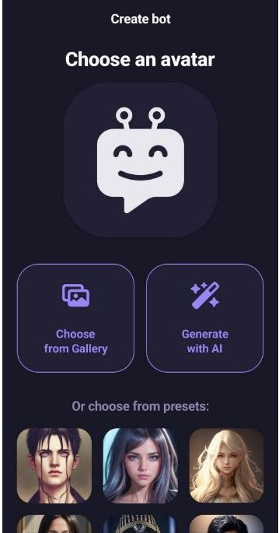
Figure 1.9– Creating personalized AI page on «Botify AI»

The application currently holds a 3.9-star rating out of a possible five, along with over 500,000 downloads, signaling mixed reactions from its user base. This substantial number of downloads paired with a less-than-perfect rating could indicate underlying issues related to user satisfaction or the stability of the app itself. The notable discrepancy between the volume of downloads and its average rating underscores the necessity for ongoing development and refinement to align more closely with user expectations and needs. Additionally, the application offers various in-app purchases that provide access to additional features and content, potentially enriching the user experience if appropriately utilized (figure 1.10).

Figure 1.10 – In-app purchases on «Botify AI»

Botify AI's interactive features include photo sharing, multi-topic conversations, and chat management, giving it flexibility for entertainment, learning, and stress relief through virtual interaction. The latest update was on March 15, 2024, indicating that developers are actively working on improvements, which could lead to a better user experience.

1.3.2 Analysis of analogues in Kazakhstan

In the previous section, we emphasized the importance of comparing current virtual character apps and websites to understand best practices and identify areas for improvement. This section will focus on similar apps and websites in Kazakhstan that indirectly provide the same features as the planned app and website.
Studying similar services in Kazakhstan will offer valuable insights into local market trends. Understanding which features are popular in Kazakhstan will help tailor the app and website to fit the preferences and needs of the local audience. Understanding the local culture and context will guide changes to make the website and app more accessible and relevant for everyone involved. This section aims to analyze the existing platforms and websites dedicated to AI-based virtual characters in Kazakhstan. Moreover, exploring similar services in Kazakhstan will aid in adapting the app and website to meet the preferences and needs of the local audience, ultimately enhancing its relevance and accessibility in the region.
«Chatbot.kz»
The website chatbot.kz specializes in creating chatbots for different platforms like websites, WhatsApp, and Telegram. They offer both text and voice bots for customer support, sales, marketing, and more, across many industries. The site emphasizes that their bots are efficient, easy to access, and reduce stress by operating 24/7 without needing extra hardware. For businesses in Kazakhstan, chatbot.kz is a promising option for using AI chat solutions to improve customer interactions and efficiency.
The chatbot.kz website design uses a clean, modern look with cool blues and bright green highlights that inspire confidence and innovation (figure 1.11). Flat design for icons and graphics gives a modern feel and makes the user interface easier to navigate. The top menu is simple, providing easy access to important information. The chatbot illustration effectively highlights the site's focus on automated digital assistants. This high-tech, clear design approach makes information attractive and easy to understand for potential clients.

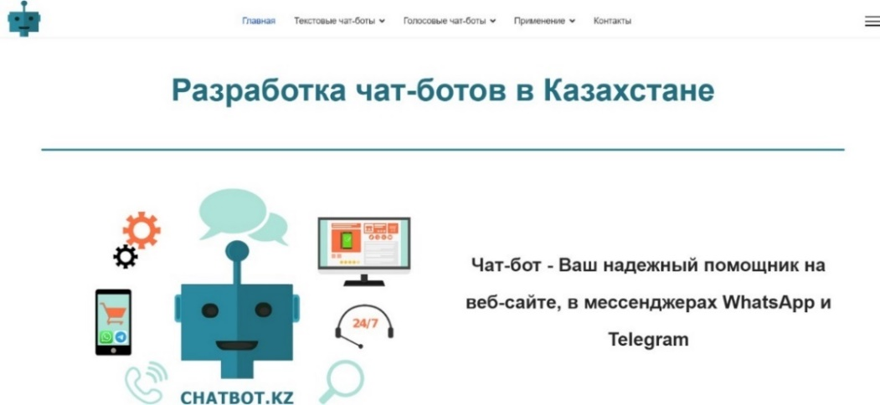
Figure 1.11 Main page on «chatbot.kz»

Their chatbots can be used for customer support, sales, marketing, government services, recruitment, debt collection, delivery services, education, and information business. This wide range shows that chatbot.kz customizes its chatbot technology to automate and improve different business operations, potentially reducing costs while increasing efficiency and customer engagement across sectors.
«tengri-ai.kz»
Tengri AI markets itself as the first Kazakhstani 'live' Telegram Bot with advanced AI, powered by OpenAI's GPT-4. It offers services like content planning and post formatting for social media, text editing and translation, voice-to-text, and text recognition from images to improve business operations. Tengri AI also helps with educational and coding tasks, providing an interactive chatbot for discussions on many topics to enhance communication with new technologies.
The Tengri AI landing page features a vibrant, futuristic design that immediately highlights its main product, Tengri Bot, the first Kazakhstani 'live' Telegram Bot with advanced AI (see Figure 1.12). The design uses a dynamic 3D image of the bot on a smartphone, showing the interactive nature of the product. The color scheme of purples and blues represents innovation and trust in technology. The clear call-to-action button invites users to start right away, promising a smooth user experience. This visual style fits well with AI technology's innovative appeal.

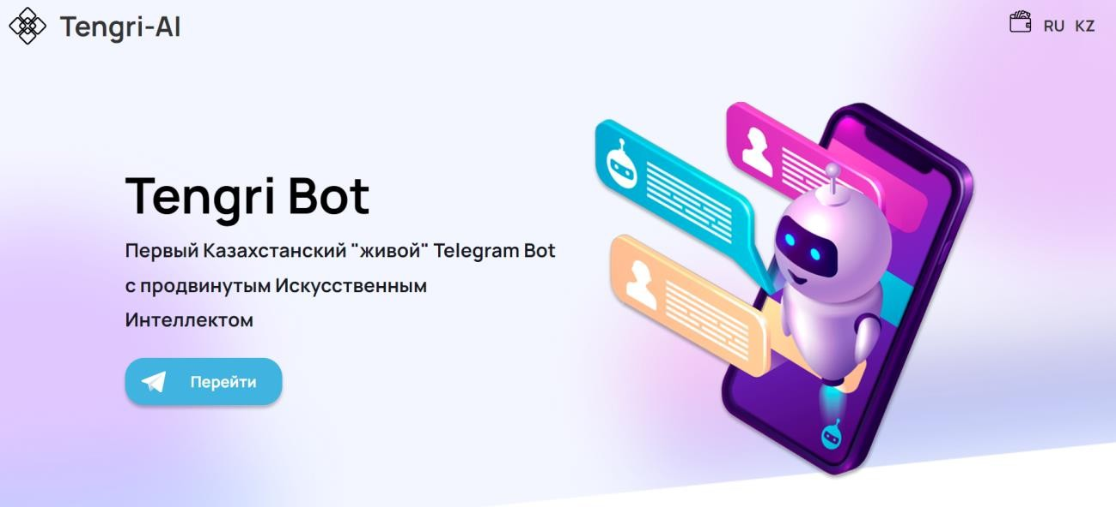
Figure 1.12 Main page on «Tengri-AI.kz»

Websites such as Tengri AI and chatbot.kz provide a broad array of chatbot services, yet they do not deliver a product precisely akin to ours. Our offering, an AI-powered virtual character, introduces a distinctively immersive interaction, extending beyond mere text-based chatbots. It integrates an animated virtual persona with a unique personality, fostering a richer, more interactive user experience. This enhancement is unmatched in the local market, positioning our project as a pioneering example of advanced AI technology in Kazakhstan. This innovation not only differentiates our product but also enhances user engagement by providing a more human-like interaction, making it a significant advancement in the digital interaction landscape.

1.3.3 Comparative analysis of existing analogues

The Ask AI mobile app leverages ChatGPT-like AI to generate various texts, from stories and poems to translations. Its intuitive interface provides advice on topics like generating online income and features in-app purchases for extra content. Designed for writers, educators, and professionals, "Ask AI" supports creative and educational activities, showcasing AI's potential in enhancing learning and professional skills.
The Nova is versatile AI chatbot and assistant powered by ChatGPT, GPT-4, and Palm M.2, Nova answers questions, generates new ideas, and broadens knowledge. It offers image generation, AI conversations, and text summarization, enhancing learning and content engagement. Nova features in-app purchases and an easy-to-use interface, catering to educational, professional, and personal interests. It also recommends books and movies, making it a highly adaptable and engaging platform.
The Digital Mate desktop companion app, Digital Mate provides interactive entertainment and reminders with a straightforward interface. It integrates kinesthetic interaction and uses a lightweight rendering engine to minimize system resource usage. Despite positive reception, discrepancies between recent and overall feedback highlight potential areas for improvement in stability.
The Botify AI is app allows users to craft and interact with AI bots, offering various characters for customization. It supports creating AI companions, role-playing, and thematic conversations, encouraging engagement and personal expression. Botify AI includes in-app purchases and targets users seeking entertainment, educational content, and stress relief through virtual interactions.
The Chatbot.kz website creates custom chatbots for websites, WhatsApp, and Telegram to automate customer support, sales, and marketing. These bots offer 24/7 service without additional hardware, improving engagement and reducing costs across sectors like customer service, government, sales, and recruiting.
The Tengri AI providing a Telegram bot powered by OpenAI's GPT-4, Tengri AI offers services like content scheduling, text editing, translation, voice-to-text, and image recognition, enhancing business operations. It also supports education and coding tasks by acting as an interactive AI conversation partner.
After reviewing the features offered by different AI platforms, a comparison shows that Ask AI, Nova, Digital Mate, and Botify AI share core functions, like allowing users to register online. But Chatbot.kz and Tengri-ai.kz don't have this feature. Regarding mobile apps, Ask AI, Nova, and Botify AI have popular mobile apps on the Play Market. Digital Mate stands out with a desktop app, which is unusual in a market where mobile apps are more common, likely because people prefer mobile. Ask AI, Nova, Digital Mate, and Botify AI have chat windows, which are key for chatbot communication. Chatbot.kz and Tengri-ai.kz also let people chat, but through messaging apps, so their user experience is different. Ask AI, Nova, Botify AI, Chatbot.kz, and Tengri-ai.kz support payment, but Digital Mate does not. Instead, it charges a small fee of $2.99 on the Steam platform, following a different payment strategy.
A unique feature of Digital Mate is its 3D model in the desktop app, making it stand out among chatbots. Ask AI, Nova, Botify AI, Chatbot.kz, and Tengri-ai.kz offer report generation, showing that analytics and feedback are valued for improving user experience. Nova, Digital Mate, and Botify AI let users choose a character, a feature missing in other platforms, which either have one chatbot or no selection at all. Ask AI, Nova, Botify AI, Chatbot.kz, and Tengri-ai.kz all offer customer support, but Digital Mate is less responsive, with many complaints going unresolved (table 1.1).

Table 1.1 Comparison of analogues
Feature | Ask AI | Nova | Digital Mate | Botify AI | Chatbot.kz | Tengri- ai.kz
Registration | Yes | Yes | Yes | Yes | No | No
Mobile app | Yes | Yes | No | Yes | No | No
The continuation of the Table 1.1

Web app | No | Yes | No | Yes | Yes | Yes
3D Character | No | No | Yes | No | No | No
Reporting | Yes | Yes | No | Yes | Yes | No
Chatting window | Yes | Yes | Yes | Yes | No | No
Payment processing | Yes | Yes | No | Yes | Yes | Yes
Character management | No | Yes | Yes | Yes | No | No
Customer support | Yes | Yes | No | Yes | Yes | Yes

Each platform has different features and pricing to meet various needs and preferences. It's important to carefully review your specific needs before choosing the best app.
Advantages of our proposal include:
      - Our plan is to build an app that combines the best features of current platforms, with a focus on adding a 3D model for a virtual character. We'll use apps that the community rates highly to help with this.
      - To make interacting with virtual characters easier, we're creating a website where users can choose different characters. Voice modulation for these characters will use algorithms from elevenlabs, known for their advanced voice synthesis technology.
      - We aim to provide a simple, user-friendly interface. Along with the interface, we will create a video tutorial on the website to help users get the most out of the app.

1.4 Analysis of virtual character and web-site development tools

In this section, we'll explore the tools and applications used in developing websites, which are crucial for building our app and website. Choosing the right development tools is essential for making sure our product is effective and works well, as these tools shape its features, design, and user experience.
There are many options on the market for website and app development tools, including content management systems (CMS), website builders, and programming languages. Each one has its own strengths and weaknesses, so we must choose carefully based on the specific needs of our product.
We'll closely examine the development tools available to understand their pros and cons and find the best fit for our project. Selecting the right tools is crucial to ensure the application and website work perfectly, look attractive, and are easy to use, providing a great user experience.
The term "development" refers to both the creation and upkeep of a product. Building a website involves many programming languages, while app development often relies on one language along with frameworks specific to that language. Before diving into the different tools for app and website development, it's important to understand the basics of how they're built. The three key languages for websites are HTML, CSS, and JavaScript. They form the foundation of any website and are crucial for developers to know. For apps with graphical user interfaces, languages like Java, Python, and C# are used.
First, we'll focus on the tools for building websites. HTML structures the website content, CSS defines style and layout, and JavaScript adds functionality and interactivity. We'll provide a detailed overview of each language, explaining their roles in website and app development. We'll also review the pros and cons of each language and give resources for further learning.
HTML stands for Hypertext Markup Language, and it is the standard markup language used to create web pages [6]. The "HyperText" part refers to the fact that HTML allows you to create links that allow visitors to move from one page to another quickly and easily [7]. HTML uses elements and tags to structure web content, allowing developers to create sections, paragraphs, headings, links, and various media like images and videos. It's the backbone of most websites, with CSS (Cascading Style Sheets) and JavaScript added to handle design and behavior.
The advantage of HTML is that it's widely accepted and standardized, so web pages made with it can be viewed on many web browsers, no matter the device or platform. Another benefit is that HTML is free. Developers don’t need to purchase licenses or additional software to create HTML content [8]. This makes HTML very beginner- friendly, especially for those new to web development. There are also many tutorials and training programs available specifically for HTML, making it easier for aspiring developers to learn.
HTML has limitations when trying to create dynamic, interactive web experiences on its own. While HTML5, the latest version, adds more interactive features, it still needs CSS and JavaScript to fully create modern and advanced web applications.
CSS describes how elements should be rendered on screen, on paper, in speech, or on other media [9]. CSS separates the content's layout, colors, and fonts from the actual text, giving developers more control over how elements look across multiple pages. This separation makes content more accessible, allows for consistent styles across web pages, and reduces repetitive code. One of the most significant advantages of CSS is its ability to separate content from presentation [10]. By setting up style rules, developers can keep a consistent look across a website, improving the user experience. CSS also speeds up page loading by reducing the amount of code needed in the HTML document.
Despite the benefits, CSS also has challenges. Its cascading nature can make it tricky to figure out how styles apply, especially in large projects with many stylesheets. Mastering CSS requires understanding selectors, properties, values, and the box model, which can be overwhelming [10]. This complexity makes debugging and maintaining the code difficult. Different web browsers also interpret CSS rules differently, causing web pages to look inconsistent across browsers.
To overcome these challenges and use CSS effectively, developers can use resources like official documentation, tutorials, and online communities. Taking the time to explore and understand documentation can empower you to leverage the full potential of these tools, troubleshoot issues effectively, and optimize your code for superior performance [11]. Engaging with these resources can deepen your knowledge of CSS, helping you build visually attractive, responsive, and user-friendly web pages.
After covering HTML and CSS, it's important to look at JavaScript, a programming language that adds dynamic and interactive features to web pages. JavaScript was introduced in 1995 to add programs to web pages in the Netscape Navigator browser [12]. JavaScript works on the client side of the web, allowing for interactive features like form validation, animated graphics, and complex layouts. It's key for developing rich, interactive web applications that connect static HTML/CSS content to user actions.
JavaScript isn't just for client-side scripting. With Node.js, an open-source, cross-platform runtime environment, JavaScript also works for server-side programming. Node.js helps developers create fast and scalable network apps, showing JavaScript's value for full-stack development. It uses an event-driven, non-blocking I/O model that makes it efficient for data-heavy real-time apps running across multiple devices.
JavaScript isn't just for client-side scripting. With Node.js, JavaScript is now also used for server-side programming. Node.js is an open-source and cross-platform JavaScript runtime environment [13]. It helps developers build fast and scalable network apps, showcasing JavaScript's value for full-stack development. Node.js uses an event-driven, non-blocking I/O model, making it efficient and perfect for data-heavy real-time apps across many devices.
The JavaScript ecosystem includes many frameworks and libraries that boost productivity and app performance. Vue is a framework and ecosystem that covers most of the common features needed in frontend development [14]. Unlike big frameworks, Vue is designed to be gradually adoptable. Its core library only focuses on the view layer, so it's easy to add to existing projects or use with other tools. Package management in JavaScript is streamlined through Node Package Manager (npm), which facilitates the sharing and distribution of code. npm is the world's largest software registry [15]. Node Package Manager not only lets developers install JavaScript libraries and frameworks, but also handles dependencies well to keep projects updated and secure.
For building SPAs or complex user interfaces, the "router view" concept is essential. Router views map components to specific routes, letting apps load components dynamically without reloading the whole page. This creates smooth, app- like navigation and enhances the user experience.
In web apps, using APIs is more important than ever. Axios is a promise-based HTTP Client for node.js and the browser [16]. It makes it easier to send asynchronous HTTP requests to REST endpoints and perform CRUD (Create, Read, Update, Delete) operations. It’s simple API and ease of handling requests and responses make it a favorite among developers, including us.
Moving from web application development, with its emphasis on JavaScript frameworks and libraries for dynamic user interfaces, to standalone application development, involves a shift to more comprehensive programming environments. In this realm, the .NET framework and the C# programming language become essential.
The .NET is a free, cross-platform, open-source developer platform for building many kinds of applications [17]. It provides a rich library that simplifies tasks like database interaction, networking, and XML document handling. This makes it versatile for building everything from web and mobile apps to Windows-based applications.
C#, created specifically for .NET, is a modern, object-oriented programming language offering efficiency, scalability, and flexibility. It's perfect for building applications with graphical user interfaces, complex data processing, and real-time performance.
Switching from web to application development shifts the focus from client-side scripting to software architecture, performance optimization, and cross-platform compatibility. .NET and C# support both web and standalone apps, letting developers use their web skills while accessing extensive tools and libraries in the .NET framework. For instance, like how Axios manages web API requests in JavaScript, .NET provides HTTP Client for sending and receiving HTTP requests via URI. Entity Framework simplifies database management with object-relational mapping, allowing developers to work with objects without directly handling SQL syntax.
NuGet, Microsoft's package management system, makes managing dependencies within .NET efficient. With NuGet, developers can easily find, install, update, and remove third-party libraries. Its versioning system ensures compatibility across projects, providing precise control over dependency resolution. NuGet integrates smoothly into the .NET ecosystem, supporting various project types like class libraries, console applications, and web projects. This includes, but is not limited to, sophisticated tools such as Elevenlabs and Character AI, the latter of which relies on the robust functionalities offered by puppeteer-sharp [18].
A well-configured development environment is key for smoothly integrating and using packages like those provided by NuGet. This is important for advanced tools like Elevenlabs and Character AI, which depend on puppeteer-sharp, highlighting the need for a strong, flexible development setup. Choosing a development environment is crucial in software development, requiring careful evaluation. We chose Microsoft Visual Studio after comparing it to Rider IDE by JetBrains.
Microsoft Visual Studio stands out as a premier integrated development environment (IDE) that caters to a wide range of programming tasks across various languages and platforms. Renowned for its robust functionality, Visual Studio offers developers a comprehensive suite of tools that enable them to handle the entire development cycle within a single interface. Visual Studio is a powerful developer tool that you can use to complete the entire development cycle in one place [19] (figure 1.13). It helps develop complex software and manages the whole lifecycle, from development to testing and deployment. This was the rationale behind the selection of this tool.
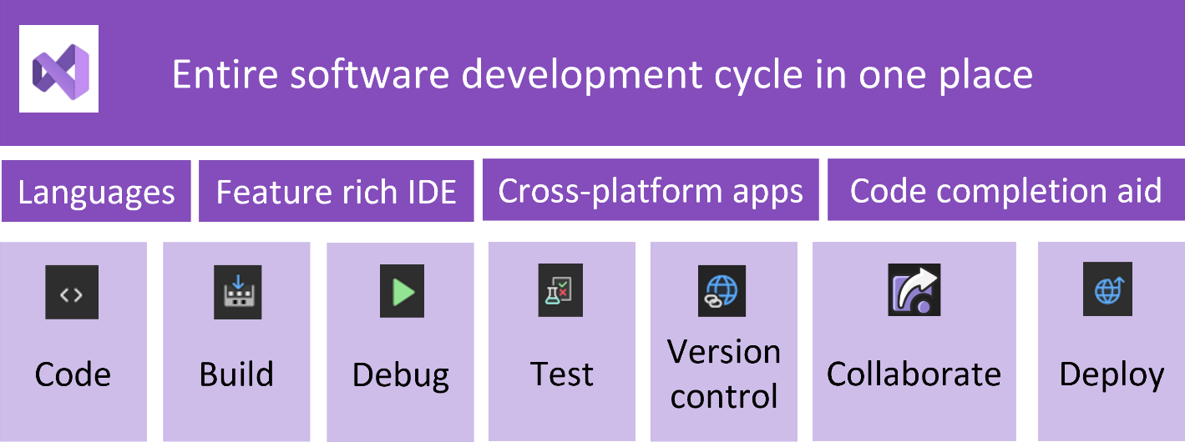
Figure 1.13 – Visual Studio functionality.

Rider IDE from JetBrains is known for its strong cross-platform features, offering a robust development environment for .NET applications. It has advanced code navigation, refactoring tools, and version control integration. Rider is also recognized for handling large codebases efficiently. We chose Microsoft Visual Studio over Rider because of specific project needs, our team's familiarity with Visual Studio, and its extensive support for our planned development technologies. Although Rider was an attractive option, especially with its cross-platform development features and efficient code analysis tools, Visual Studio's integration and tools better suited our project's goals.
This choice shows how important it is to match the development environment with the project's technical needs, the team's expertise, and the overall development strategy. Each environment has strengths and trade-offs, so careful evaluation is crucial.
Visual Studio supports many programming languages like C#, VB.NET, C++, and JavaScript, allowing developers to work in one environment regardless of the project's language. This streamlines the development process. Visual Studio's debugging tools are among the best in the industry, providing breakpoints, code stepping, variable inspection, and performance profiling. These helps identify and fix bugs. The IDE also integrates testing tools for unit testing, UI testing, and load testing, ensuring software reliability.
Another great feature of Visual Studio is its advanced code editor, which includes syntax highlighting, IntelliSense (code completion), and code refactoring. These features boost coding efficiency and make the code easier to read and maintain. Visual Studio also has version control support, integrating with Git and other systems to help with collaborative development.
Git, a distributed version control system, is vital for managing code repositories and teamwork. It was created by Linus Torvalds in 2005 and has been maintained by Junio Hamano since then [20]. Git manages projects of all sizes efficiently, letting developers track and manage code changes. Git's distributed nature sets it apart. Unlike centralized systems, each developer's Git directory is a complete repository with full history and version- tracking abilities. This independence improves collaboration, letting developers work freely and merge their changes later. Git's branching model is simple and powerful, making branching and merging fast and easy. This supports features like feature branching, task branching, and exploratory branching, letting developers keep their work separate and maintain the main repository's integrity.
When integrated with Visual Studio, Git's utility grows, streamlining the workflow. Developers can run Git commands directly from the IDE, boosting productivity by reducing context switching. This integration supports basic and advanced Git functions, like branch management and merging.
After mastering Git, we understood its power as a version control system, helping us track changes in our projects. However, Git lacks the structure and timeline management needed for overall project development. To fill this gap, we looked for a tool that could manage version control, project management, task allocation, and deadlines.
After exploring many project management tools, we found that Notion provides the right mix of features to organize our development process. Notion's versatility lets users create a workspace that includes task lists, project timelines, databases, and documents. It can be customized to fit specific project needs, from software tracking to content calendars.
Notion is an all-in-one organization and collaboration platform that's popular among individuals and businesses. Launched in 2016, it's flexible and combines note- taking, task management, databases, and wikis. Users can customize their workspace to fit their needs, whether for personal planning or managing projects in a corporate setting. Notion uses a "blocks" system, which lets users create content like text, images, tables, and Kanban boards. These blocks can be assembled to build pages and create a customized digital workspace, whether for personal use or collaboration. Notion's deeply nested structure lets users create pages within pages, providing a high level of organization. This keeps large amounts of information organized and easy to access.
For teams, Notion's real-time collaboration tools allow for sharing, comments, and editing. The permissions settings protect sensitive information. Although its features can be overwhelming for new users, there are many resources to help people make the most of Notion. Capture thoughts, manage projects, or even run an entire company — and do it exactly the way you want [21].
Once tasks are assigned in Notion, it's important to explore the tech frameworks needed to develop the application. The app's key feature is a virtual assistant that can talk to users. This requires audio output features for the digital assistant, and ElevenLabs provides advanced voice synthesis technology that makes the virtual assistant's voice interactions lifelike.
ElevenLabs is a leader in AI-driven voice technology, providing tools for generating, customizing, and cloning voices. ElevenLabs offer high-quality pre-made voices, a Voice Design feature that allows you to create unique voices, and two different types of voice cloning features: Instant Voice Cloning and Professional Voice Cloning [22] (figure 1.14). The platform collaborates with professional voice actors to ensure that voices are sourced legally and through paid partnerships that respect the artists' rights.
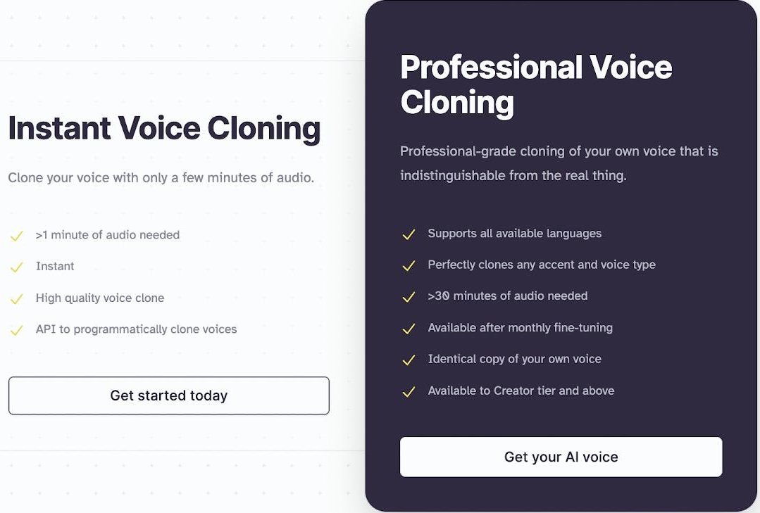
Figure 1.14 – Instant Voice Cloning and Professional Voice Cloning.

The company's VoiceLab suite helps users create highly accurate digital voices. It can use short samples for instant cloning or larger sets for professional cloning. ElevenLabs emphasizes security and responsible use, ensuring users have the necessary rights and permissions, showing the company's commitment to ethical practices.
ElevenLabs' technology is used in many areas, like podcasting, gaming, audiobook narration, and language dubbing. Notable applications include entertainment projects needing voice replication or enhancement and publishers creating AI-narrated audiobooks. After acquiring the audio and text for our virtual character, the next step is to create a 3D representation. VTube Studio is a useful tool, using real-time motion capture to develop and animate virtual avatars. It works with webcams or mobile devices to bring characters to life, helping creators produce engaging, interactive content.
Though VTube Studio was primarily made for live streaming, it can also be adapted for our project. It will serve as a key tool in our thesis work. In the future, we might explore creating a custom platform tailored to our specific research. VTube Studio is designed for virtual YouTubers (VTubers) and content creators who use animated avatars for streaming or video production. The app uses your smartphone or webcam to track your face and animate a Live2D Cubism Model accordingly [23]. It's user-friendly and customizable, catering to both new and experienced creators.
To refine models, Blender is an excellent choice. It's a free, open-source 3D graphics software used for animated films, visual effects, art, 3D models, games, and more. Blender has a wide variety of tools making it suitable for almost any sort of media production [24].
Blender offers many modeling tools for creating and refining detailed 3D models. Features like sculpting, non-destructive editing modifiers, and mesh editing make complex designs easier. Sculpting tools add fine details like textures and wrinkles to make models realistic. Blender also excels in texturing and shading, supporting procedural and image-based textures. Its node-based material system creates detailed materials for depth and realism.
Blender includes Cycles and Eevee render engines, which provide high-quality rendering essential for presenting polished models. These engines offer advanced lighting and shadowing techniques for visually stunning results. As an open-source tool, Blender allows extensive customization through add-ons, improving modeling workflows with features that make refinement smoother. Blender is backed by a large community of users and developers who offer tutorials, forums, and downloadable assets. These resources are valuable for mastering advanced techniques and solving specific modeling problems. Professionals, hobbyists, and studios around the world use it for creating animations, game assets, motion graphics, TV shows, concept art, storyboarding, commercials, and feature films [24].
At the same time, thorough testing of web applications is crucial. Web API testing ensures functionality and reliability, which is why Postman is used. Postman is a powerful tool that helps developers create, test, and manage APIs. API acts like an interface between a couple of applications and establishes a connection between them [25].
Postman features automated testing, comprehensive documentation, and lets teams share API request collections for better collaboration. Good documentation helps the people who use your collection understand what it does and how each request works [26]. By using Postman early in development, potential issues can be fixed before they become bigger problems, saving debugging time later. Using Postman also helps make development more structured and systematic, improving workflow and code quality. As web tech evolves quickly, tools like Postman support agile practices and continuous integration. Postman is a third-party tool, so developers may become overly reliant on it and not develop a strong understanding of APIs and other development tools [27].
In the first chapter, we explored various websites and apps centered around AI virtual characters, leading to a detailed analysis in this chapter on methodologies for creating these AI entities. We delved into the motivations for developing a new app, and conducted a comparative analysis that spans both global and local (Kazakhstan-specific) examples. This analysis helped us identify trends, set benchmarks in the field, and choose the appropriate tools and strategies for our new platform.
Our comparative analysis not only evaluated the technical aspects, like features and AI realism, but also examined how platforms cater to user needs. This approach has allowed us to craft a dynamic AI character that utilizes cutting-edge technologies to predict and adapt to user preferences. The insights gained have guided our strategic decisions, ensuring that our platform is innovative, responsive to evolving digital trends, and capable of delivering a transformative user experience.

2 DESIGNING THE WEBSITE AND APPLICATION FOR VIRTUAL CHARACTERS BASED ON AI

2.1 Functional requirements

The Software Development Life Cycle (SDLC) is a process that outlines the stages and activities involved in developing software from conception to deployment and maintenance (Wang, & Elhag, 2006) [28]. The detailed development process includes several key stages:
Planning: this is the first stage, where the project's scope is set, and the requirements for the website and application are described. It involves creating timelines and a detailed project plan. This step is vital for making sure the project's goals are clearly understood and match the needs of stakeholders, including the application's features and virtual character integration.
Design: this stage creates wireframes, mockups, and prototypes for both the website's layout and user interface, as well as how people will interact with the virtual character in the application. Feedback from stakeholders is important at this point to improve the design and ensure it meets expectations for both the website and the application.
Development: moving from design to development, this phase builds the website and application using chosen technologies. Special attention is given to developing the voice response abilities and virtual character interactions. Following best practices is crucial to create a strong and secure system that can handle the application's features.
Testing: thorough testing is done to check how well the website and application work, how easy they are to use, and how secure they are. This includes testing the accuracy of voice recognition and response, the virtual character's performance, and the overall user experience. Finding and fixing any issues now is important for the final product's reliability and performance.
Deployment: after testing, both the website and application go live. This stage includes improving performance, ensuring security measures are in place, and preparing the systems for real users.
Maintenance: regular maintenance is essential to keep both the website and application up-to-date and secure. This means regular updates, bug fixes, and applying security patches, especially for apps with real-time user interaction and data processing.
By following these steps, we can deliver a high-quality website and application that meets user needs and is safe, expandable, and easy to maintain. This structured development process is crucial for applications with advanced features like voice responses and virtual characters to ensure they can keep up with changing technology and user expectations. Our unique product, featuring an AI-powered virtual character with its own animations and personality, provides a uniquely immersive and interactive experience. Next, we'll look at the basic requirements for both the website and application.

2.1.1 Functional Requirements for the Website

Website development is a systematic process that involves several phases to ensure a successful and well-functioning website [29]. In the initial phase of website development, it's crucial to clearly outline the necessary features and specifications the website needs to have. The website design should focus on a user-friendly interface that makes it easy to navigate and quickly access key features. Here’s what the website should include:
- User Registration and Authentication: new users should be able to sign up to create an account, then log in using their unique credentials.
- User Profiles: each user should have their own profile where they can manage their personal information, see their activity, and track their participation in events.
- Receive Tokens for Using AI: the website should let users choose characters and earn special tokens that can be used in the application.
- Character Discovery and Filtering: adding a search feature with user-friendly filters is important to help users find characters that match their preferences.
- Financial Transactions: setting up secure payment systems is key to handle user subscriptions and other payments, ensuring data is kept private and safe.
- Responsive Design: the website’s layout should adapt to different devices, like desktop computers, tablets, and smartphones, for the best viewing experience.
- Administrative Dashboard: the website needs a control panel so administrators can manage user accounts and website features easily.
- Cybersecurity Measures: strong security rules must be in place to protect user information, prevent fraud, and keep the platform safe for everyone.
Including these features is crucial for providing a smooth user experience, helping people easily choose virtual characters and manage their accounts. The design should be modern, simple, and consistent across all parts of the website, paying close attention to typography, colors, and graphics. The layout should be clear, reducing distractions, and focusing on clear, easy-to-understand actions. The user interface should also be optimized for different devices and made accessible to people with disabilities, so more people can use and enjoy the website.

2.1.2 Functional requirements for application

The Integration of Advanced Technologies presents an opportunity for applications to harness cutting-edge innovations [30]. For an application with voice feedback and a synchronized virtual avatar, it's important to carefully set up key features and specifications that align with the goal of providing an interactive and engaging digital experience. The application should include the following:
- Virtual Character Personalization: users should be able to select their preferred virtual character from a selection available on the website. They should also be able to choose the character's voice, making the interaction more personal.
- Voice Interaction and Synchronization: the application should have voice recognition technology that understands user commands and provides spoken responses in sync with the virtual avatar’s movements, creating a smooth audiovisual experience.
- Data Security: the application must include strong security measures to protect user data, prevent unauthorized access, and maintain the integrity of interactions between the user and the virtual character.
When designing the application, the user interface and overall visual design are crucial. The design should be modern and simple, focusing on easy navigation and a minimalist style. Typography, colors, and images should match the brand. The interface itself should be clear and welcoming, providing an intuitive and easy-to-use experience. Our application's design should be seamlessly integrating these advanced features, ensuring that users not only appreciate the aesthetic and functional aspects but also enjoy a deeper connection with the virtual character.

2.2 Design Techniques

This section aims to provide a detailed description of the processes and strategies used to design the system. This includes defining use cases to keep track of all user interactions, designing and drawing ER diagrams to ensure a well-organized database, and defining service architectures to create a fault-tolerant and efficient system infrastructure. Each method was chosen to improve system functionality, and ease of use, and enable future modifications with minimal disruption.
By detailing these design methods, we aim to create a transparent framework that our development team can easily understand and implement. In addition, this planning helps avoid common software development mistakes such as poor scalability, maintenance difficulties, or security vulnerabilities. Ultimately, the methodologies described in this section are vital to laying a solid foundation for the successful implementation and lifecycle management of a software product.

2.2.1 Defining Use Cases

After identifying the functional requirements, we need a framework to guide our next steps in development. To do this, we first determine the types of users and the features available to them. A use case diagram was created to map this out [figure. 2.1 (see Appendix A)]. Use cases describe the functional requirements of a system from the end user's perspective, creating a goal-focused sequence of events that is easy for users and developers to follow [31]. First, we identified the types of users who will interact with the application. These include regular users who want to use the platform to create content, such as lessons, or seek social interaction. Administrators can access the administration panel and have full control over the website's operations.
According to the use case diagram, all user types can access basic features like registration, logging in and out, profile management, choosing virtual characters, interacting with them, and earning tokens. Administrators, however, have full access, allowing them to add or remove users, block or unblock accounts, and oversee financial transactions. This capability ensures that administrators can effectively manage user interactions and maintain the integrity and security of the platform.
Furthermore, our platform distinguishes itself by offering a highly interactive AI-powered virtual character that goes beyond simple text-based responses. This virtual character has its own animations and personality, providing a rich, immersive experience that is currently unparalleled in the region. By enabling users to interact with a dynamic virtual entity, our application not only enhances user engagement but also sets a new standard for how AI technology can be utilized to create meaningful and engaging digital experiences. This unique approach puts us at the leading edge of AI application development in Kazakhstan, showcasing our commitment to innovation and quality in delivering exceptional digital products.

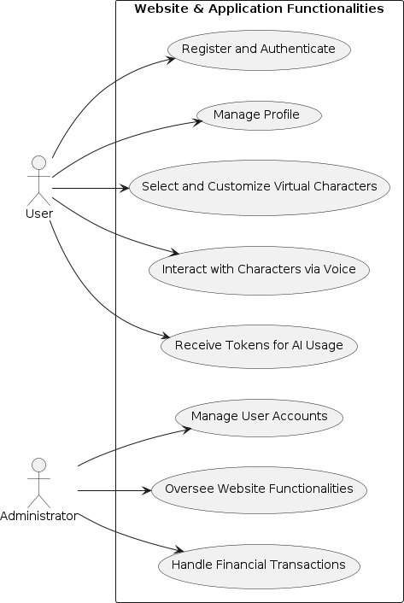
Figure 2.1 – Use Case

2.2.2 Designing ER-Diagram

After gaining a clear understanding of the core functions and defining user access, our next step is to design the website's underlying framework. This involves mapping out the entities and their connections within the system, which is crucial for visualizing the content and architecture, leading to a focused development plan.
When it comes to databases, the ER model allows you to represent the structure of a database at a high level of abstraction [32]. To assist in this, we created an Entity-Relationship (ER) diagram for the website [figure 2.2 (see Appendix A)]. This diagram outlines the system's data model, showing the various entities, their attributes, and relationships, laying the groundwork for further development. The ER diagram reveals a database structure of 10 tables, covering six main entities: 'Roles,' 'Users,' 'Virtual Characters,' 'Category,' 'Elevenlabs,' and 'Character AI.' Each table has a primary key to uniquely identify each record. Foreign keys link tables to define relationships like 'one-to-many' or 'many-to-many.' For instance, the 'User_Roles' junction table connects 'Users' to 'Roles' in a 'many-to-many' relationship. Meanwhile, the 'Users' table and 'User_Tokens' have a 'one-to-many' relationship since each user is linked to a unique token. The schema shows inheritance with 'User Token' sharing attributes from 'Elevenlabs' and 'Character AI.' A link, 'User_Virtual_Character,' connects 'Users' and 'Virtual Characters.' Finally, 'Virtual Characters' are categorized through the 'Category_Virtual_Character' table. These relationships allow for a comprehensive and organized data structure. This diagrammatic representation not only aids in the database design process but also facilitates discussions among developers and stakeholders, ensuring a mutual understanding of system functionalities and requirements. It acts as a visual blueprint that guides the ongoing development and refinement of database schemas to support robust application.

1
*
1
1
*
* *

*
*
1
*
1
*
*
1
1
token Varchar
Int
id
CHARACTER_AI
token Varchar
Int
id
ELEVENLABS
virtual_character_id Int
Int
category_id
CATEGORY_VIRTUAL_CHARACTER
img Varchar
Int

name Varchar

description Varchar
id
CATEGORY
token Varchar
Int

name Varchar

image Varchar
id
VIRTUAL_CHARACTER
virtual_character_id Int
Int
user_id
USER_VIRTUAL_CHARACTERS
character_ai_id Int

elevenlabs_id Int
Int
user_id
USER_TOKENS
password Varchar
Int

first_name Varchar

last_name Varchar

email Varchar
id
USERS
role_id Int
Int
user_id
USER_ROLES
description Varchar
Int

name Varchar
id
ROLES
Figure 2.2 – ER diagram

2.2.3 Drawing UML-Diagram

Using the Entity-Relationship (ER) diagram as a guide, we have mapped out the connections between the tables. The next step is to build a Unified Modeling Language (UML) diagram [figure 2.3 (see Appemdix A)]. UML class notation is standardized, making it easy for developers to understand and communicate their designs [33]. This diagram visually represents the database and backend architecture, providing a clearer view of the database entities, their attributes, and relationships, helping developers better understand and analyze the system's design.

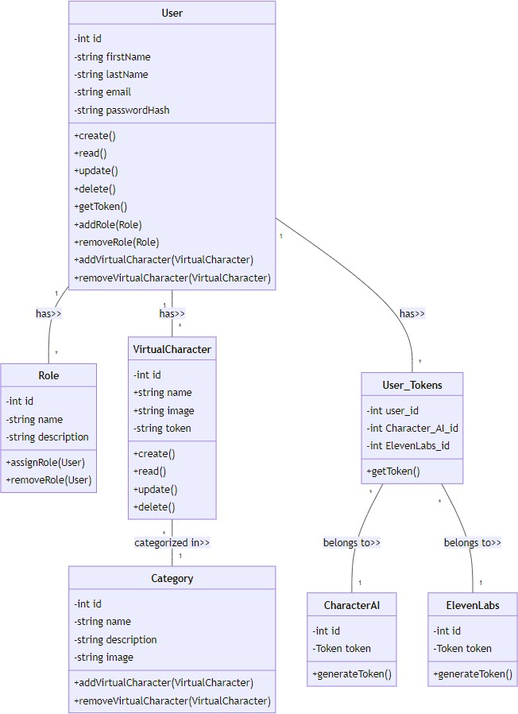
Figure 2.3 – UML diagram
In UML diagrams, we don't just show fields; we also include each entity's methods, with details like access modifiers, field types, and return types. All fields are private, preventing external classes or services from accessing them directly, which boosts security and structural integrity. Instead, public methods allow controlled access to field data, providing only the necessary functions. This design choice follows key principles of Object-Oriented Programming (OOP), like encapsulation and abstraction. Examining each entity's methods makes this architecture clearer. Below we have described the classes and methods represented in the diagram in more detail.
Class: user
- create(): makes a new User, setting up the user's ID and personal details while protecting sensitive information.
- read(): reads a User's data but excludes the password hash for security.
- update(): updates the User's details, ensuring changes follow data validation rules and security measures.
- delete(): deletes the User from the system, requiring careful data handling.
- getToken(): adds a User_Tokens token, allowing the user to access the application.
- addRole(Role): gives a Role to the User, changing their system permissions.
- removeRole(Role): removes a Role from the User, limiting their access and permissions.
- addVirtualCharacter(VirtualCharacter): links a VirtualCharacter to the User, showing ownership or control.
- removeVirtualCharacter(VirtualCharacter): removes a VirtualCharacter from the User, indicating a loss or transfer of control.
Class: role
- assignRole(User): gives the Role to a User, expanding their access in the system.
- removeRole(User): removes the Role from a User, reducing their access. Class: virtualCharacter
- create(): makes a new VirtualCharacter, creating a digital entity in the system.
- read(): reads the VirtualCharacter's data, encapsulating its digital identity.
- update(): changes the VirtualCharacter's data to update its identity.
- delete(): deletes the VirtualCharacter, erasing its digital presence.
Class: category
- addVirtualCharacter(VirtualCharacter): adds a VirtualCharacter to the Category, creating a logical grouping.
- removeVirtualCharacter(VirtualCharacter): removes a VirtualCharacter from the Category, breaking up the logical grouping.
Class: user_Tokens
- getToken(): links to tokens obtained from the CharacterAI and Elevenlabs classes.
Class: characterAI
- generateToken(): creates a unique authentication token for AI services, ensuring secure interactions and identifying AI instances.
Class: elevenLabs
- generateToken(): produces an access token for ElevenLabs services, giving secure access to their features.
The method descriptions provide a clear and standardized explanation of the tasks that each class in the UML diagram can perform. Every method outlines an essential action for managing and interacting with the different class instances in the system.

2.2.4 Defining service architecture

Our service is built using a monolithic architecture to create and manage the web- based platform [figure 2.4 (see Appemdix A)]. This design means all parts of the system, like the user interface, authorization, and token management, are combined into a single, unified application. This centralized approach makes it easier to handle all aspects of the website, simplifying both deployment and maintenance. Monoliths, on the other side, as companies grow, the monoliths grow with them, where monolith holds all classes, functions, and namespaces for the entire application, the benefits of employing a monolithic architecture include that all logic for handling a request runs in a single process [34]. However, as companies expand, their monolithic systems also grow. In these systems, all classes, functions, and namespaces for the entire application are held in one place. The benefit of using this architecture is that all the code needed to process a request runs together in a single process.

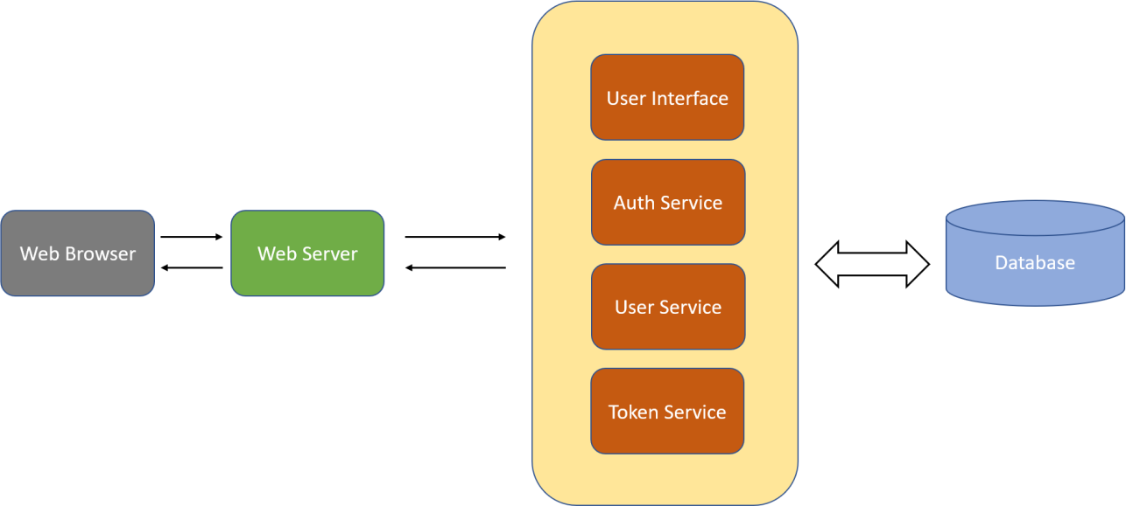
Figure 2.4 – Monolith architecture

Components:
- Web Browser: the entry point for users, responsible for sending requests to the web server and displaying the responses.
- Web Server: acts as a middleman, receiving requests from the browser and directing them to the right service in the application.
- User Interface (UI) Module offers the graphical user interface that users interact with, helping to show information and send user actions to the server.
- Authentication Service: manages the login process by verifying user credentials and maintaining security to control access.
- User Service: takes care of user data, like registration, profiles, and updates.
- Token Service: generates and manages tokens that activate virtual characters in the app, which are important for securing access to the app's features.
- Database: the main storage for all app data, keeping user info, tokens, virtual character details, and other data.
We're using a monolithic architecture because it fits our needs and abilities. This design is straight forward, reliable, and aligns with our goals, allowing our team to manage a single, coherent codebase that can be developed, tested, and deployed quickly. It avoids the extra complexity of a distributed system and allows us to focus on delivering a robust and reliable service.
Opting for a monolithic architecture offers several advantages, especially in the initial stages of development. First, it simplifies the process of development and deployment. Since all components of the application—such as the database interactions, business logic, and user interface—are integrated into a single platform, coordination between different aspects of the application becomes more manageable. This integration ensures that changes in one part of the application can be easily adapted throughout, reducing the risk of inconsistencies and speeding up the development cycle.
Moreover, a monolithic architecture can significantly enhance the performance of the application. By housing all operations within a single process, we can minimize the latency that often accompanies communication between different services in a microservices architecture. This is particularly beneficial for our application, which relies on real-time interactions and seamless user experiences with an AI-powered virtual character. Faster response times and more reliable interactions make for a more engaging user experience.
This style of architecture leverages our team's expertise in the traditional software development model, reducing training time and improving troubleshooting and maintenance efficiency. This approach not only enhances security by making it easier to implement consistent security policies across the application but also prevents breaches that can arise from different security measures across independently deployed services.
Implementing a monolithic architecture aligns with our strategic goals of launching a market-ready product quickly, allowing for faster iterations based on user feedback and market requirements without the complexities associated with managing multiple services. This method accelerates development and deployment, simplifies scaling, and facilitates upgrades as the application grows in popularity and functionality. Our solution is motivated by the architecture's alignment with our specific requirements for performance, security and speed of development, which is consistent with our goal of delivering an innovative, user-friendly and high-performance application that stands out in a competitive technology environment.
3 DEVELOPMENTS OF A WEBSITE AND APPLICATION FOR VIRTUAL CHARACTERS BASED ON AI

3.1 Desktop development

As we start developing our desktop application, we follow a key principle: using a parent process as the foundation of our design. All the processes are created when a process executes the fork() system call except the startup process [35].
The parent process acts as the manager, responsible for starting, managing, and coordinating its child processes (figure 3.1). A parent process may have multiple child processes, but a child process only one parent process [35]. The parent process assigns tasks and resources to these child processes, ensuring they work together smoothly.
Acting as the central control point, the parent process handles communication and data exchange between its child processes. This hierarchy helps maintain order within the software, providing efficient computation and smooth user interaction.

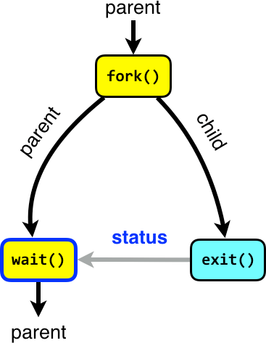
Figure 3.1 – Parent process

In short, the parent process is like the conductor of an orchestra, bringing together all the parts of desktop application development into one unified system. As the creator and manager of the application's runtime environment, the parent process shows the organized beauty found in software design and development.
In our desktop application design, the virtual character acts as the parent process in a multiprocessing system. This main process is responsible for setting up the application's environment, creating child processes, and managing how they communicate. The virtual character, like the main() function in traditional programming, is the starting point of the application.
The virtual character, as the parent process, not only controls the flow of execution but also manages the application's state, enforcing rules for how processes work together when needed. Using tools like mutexes or semaphores, the parent process can stop race conditions and deadlocks, making sure shared resources stay safe among the child processes that run at the same time.
The application will have 5 processes:
First process is CharacterAI.Client. This component acts as a dedicated interface for interaction with the CharacterAI web services. Its main job is to manage data exchange between the user's application and CharacterAI. It efficiently handles browser-based requests and responses, ensuring smooth interaction with CharacterAI. This technology generates text with subtle emotional responses and supports advanced chatbot training for highly realistic, human-like conversations.
Second process is PuppeteerLib. The PuppeteerLib is an essential module that facilitates integration with the PuppeteerSharp library, aiming to enhance browser automation within .NET framework environments. It manages browser instances and network requests, offering features like automated browser downloads, security, and stealth modes. Puppeteer controls Chrome/Chromium browsers through the DevTools protocol, mainly in headless mode, but can fully interact with browsers.
Third process is SharedUtils. This process encapsulates a collection of utility functions critical to maintaining the operational integrity of the application. It acts as a helpful tool for file management and logging across the system. SharedUtils ensures consistent and stable performance through standardized procedures.
Fourth process is VTS. VTS is an open-source library, accessible on GitHub, which was seamlessly incorporated into the existing framework of the application. It's a C# client interface to create VTube Studio plugins with the official VTube Studio API, useful for Unity and other C# environments. Changes were made after integration to align VTS with the application's requirements and expand its functionality.
Fifth process is Virtual Assistant. The central process of the application where the primary operational logic and user interface are housed. It connects the user to the application using the features provided by the other modules. This process ensures the interface is user-friendly and helps interactions go smoothly and efficiently. All processes are shown in the development environment as shown in (figure 3.2).


Figure 3.2 – Display of all processes
The CharacterAiClient process is the main way to interact with the CharacterAI service. It manages browser sessions, network requests, and sessions to communicate with AI characters. This class integrates with PuppeteerSharp for browser automation, handling browser instances and managing heavy requests while ensuring strong error handling and logging [figure 3.3 (see Appendix B)]. CharacterAiClient can manage browser sessions on its own, controlling the browser lifecycle from start to finish. It isolates each session to keep things secure and efficient. This is crucial for preventing resource leaks and maintaining good performance.
The design allows for asynchronous operations, so the client can handle multiple interactions at once without slowing down the user interface. This keeps the application responsive, which is essential when interacting with AI characters in real time. The client includes advanced methods like CallCharacterAsync and GetInfoAsync, which support features like message threads, image handling, and session continuity for a smooth dialogue with AI characters. The client has strong error handling to find and fix problems quickly. Features like EnsureAllChromeInstancesAreKilled and the IDisposable interface help clean up resources and prevent unused items from piling up. It can also manage heavy request queues, which is important when many interactions happen at once, and resources need to be carefully controlled.

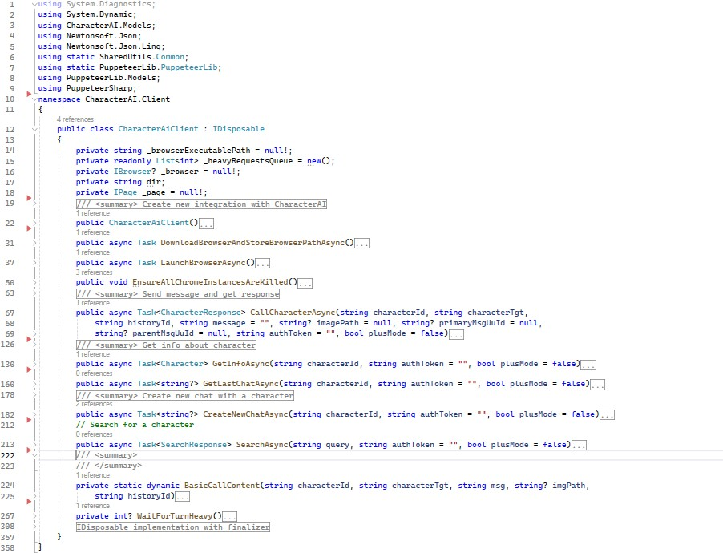
Figure 3.3 – Class CharacterAiClient
The PuppeteerLib has several important features, including browser management, creating browser instances, handling network requests, managing events, and logging [figure 3.4 (see Appendix B)].
The TryToDownloadBrowserAsync function tries to find or download the Chromium browser executable, which is essential for launching PuppeteerSharp instances. It uses events to monitor the download process, signaling its start, progress, and completion, so the app can respond to any changes. The LaunchBrowserInstanceAsync method sets up and starts a browser instance with performance and security tweaks, like turning off sandboxing and ignoring certificate errors. The StealthPlugin helps make the browser less detectable to anti-bot systems.
RequestAsync, RequestGetAsync, and RequestPostAsync functions manage HTTP requests with a PuppeteerSharp-controlled browser. They intercept outgoing requests and modify headers and payloads dynamically to meet the application's needs. FetchRequestAsync and RequestPostWithDownloadAsync are used for advanced tasks like running custom JavaScript on a page to make AJAX requests or handling file downloads directly through the automated browser.
PuppeteerLib uses an event-driven setup to handle browser downloads, efficiently managing asynchronous tasks. Events like PuppeteerDownloadStarted, PuppeteerDownloadProcessChanged, and PuppeteerDownloadEnded signal the progress. Exception handling is built-in to log and manage errors effectively. Functions like LogRed from SharedUtils.Common log error states, making debugging easier.
FetchResponse and PuppeteerResponse classes were created to handle responses from web services using a headless browser. FetchResponse interprets the raw API response to track status, queuing, and access issues.

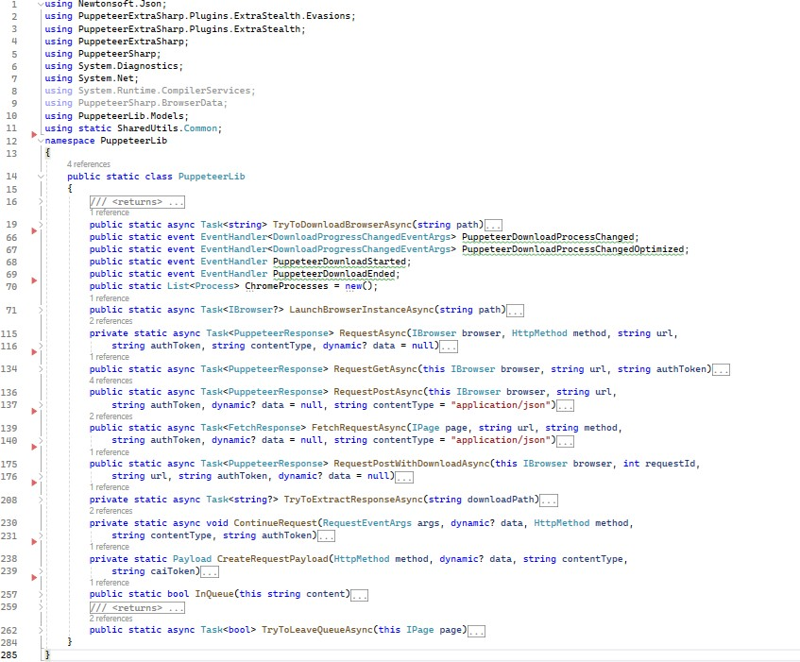
Figure 3.4 – Сlass PuppeteerLib
The SharedUtils process is a core part of the application, providing features essential for smooth operation and robust logging. It includes functions for error handling, managing directories, and handling log files, which are key for keeping the system running reliably and transparently. The Common class contains crucial constants like WarnSign and CommonDirectory [figure 3.5 (see Appendix B)]. WarnSign is a Unicode warning symbol that marks critical logs, while CommonDirectory is a central folder for important files, helping organize the application's file management.
Special logging methods, such as LogRed and LogGreen, classify log messages by severity or success, making console outputs visually clear. The generic Log method supports customizable color options, fitting various logging needs. LogRed is particularly helpful for managing exceptions, clearly marking errors and capturing full stack traces for easier troubleshooting. It ensures that critical issues are highly visible and well-documented.
The WriteToLogFile method expands the logging system to file outputs, storing all logs for auditing and review. It simplifies file operations by appending logs with a standard format, making them easier to maintain and read. The FindChromePath function is a useful part of the Common class, helping locate executable files in nested folders. This is especially important for applications that need precise control over external programs like browsers for testing or automation.

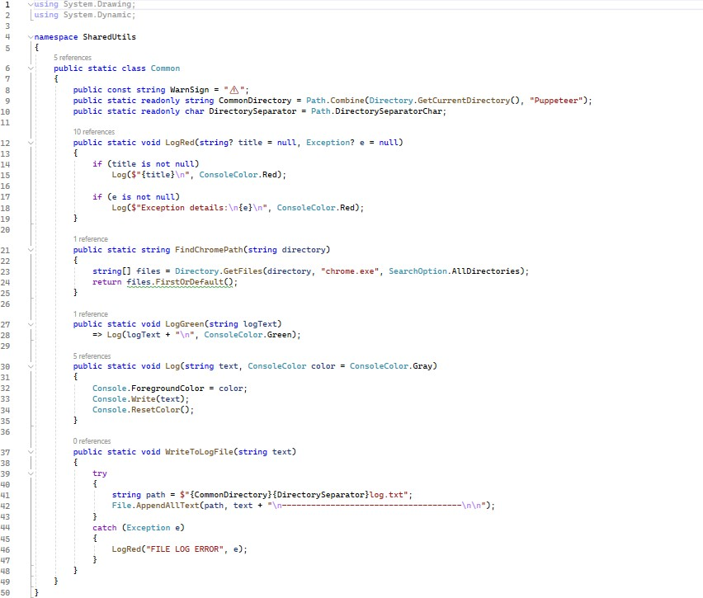
Figure 3.5 – Сlass common in namespace SharedUtils
The VTS process is part of the VTube Studio (VTS) plugin system, offering a strong base for creating custom plugins. This class integrates smoothly into VTS, providing tools for plugin management, authentication, and asynchronous operations to improve the experience for both creators and users. The CoreVTSPlugin class allows you to set plugin details like PluginName, PluginAuthor, and PluginIcon [figure 3.6 (see Appendix B)], making it easier to identify and manage plugins in VTS. This ensures a secure and user- friendly experience. CoreVTSPlugin has an asynchronous tick loop mechanism with a customizable tick interval to keep the plugin responsive and efficient. This lets it handle background tasks and updates smoothly without affecting the main app.
It includes methods for managing authentication, using ITokenStorage and IVTSWebSocket to securely store and validate tokens. This ensures plugins maintain session state with VTS for a seamless user experience. Developers can use the built-in event handling support to respond to system and user events, making plugins react dynamically to changes like connectivity issues or user actions. Finally,
CoreVTSPlugin integrates with IVTSLogger for thorough error logging and handling, which helps with debugging and development. It also ensures plugins handle runtime errors smoothly, improving stability.

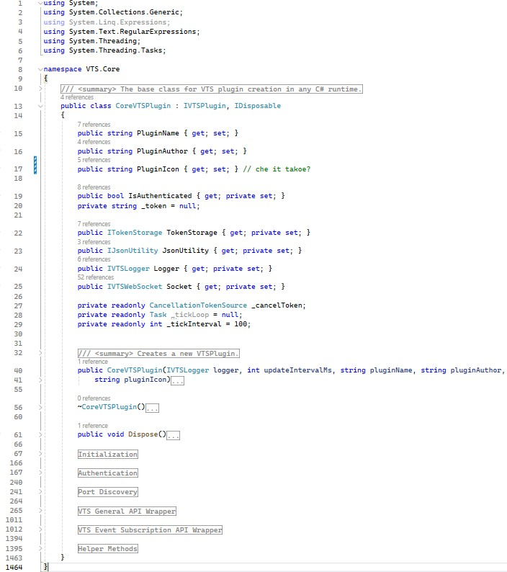
Figure 3.6 – Сlass CoreVTSPlugin in namespace VTS.core
The Assistant process is a structured software application made up of several components, each with specific roles in the system. This layered design helps deliver various features of a digital assistant. Here's a breakdown of its structure and possible responsibilities (figure 3.7). The Dependencies directory contains external libraries or packages that the project relies on. This shows that the project uses third-party tools for certain features or to simplify complex tasks.

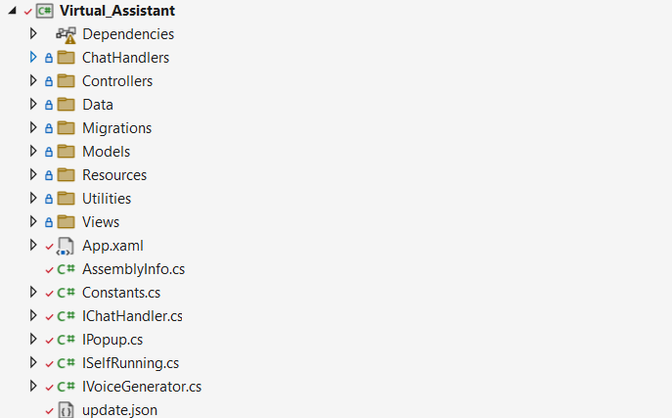
Figure 3.7 – Assistant process package management

The ChatHandlers collection of classes responsible for processing and managing chat interactions. The CharacterAiChatHandler class within the ChatHandlers namespace exhibit distinct functionalities that managing chat interactions in the application. The classes implement the IChatHandler interface, common contract for chat-related operations such as sending messages and handling responses. Here's a closer look at class [figure 3.8 (see Appendix B)].
CharacterAiChatHandler class injected with settings, an API client for Character AI, messaging service, a chat channel, and a roleplay character. It includes an asynchronous initialization method that ensures it's a singleton-like operation within a given context, presumably to set up connections or state required for chatting. Capable of sending messages and handling AI-generated responses asynchronously, which are then processed and passed along to subscribers via events. Defines two events, CompleteMessageGenerated the PartialMessageGenerated, used to communicate the chat message life cycle to other components.
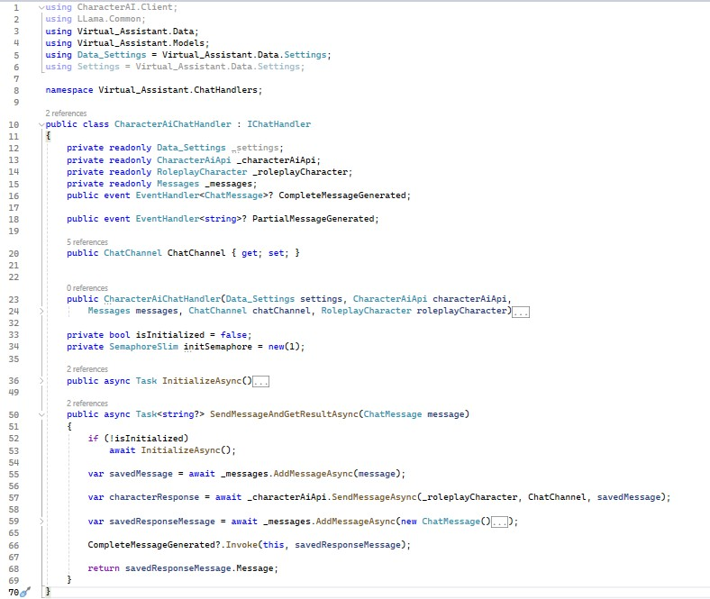
Figure 3.8 – Сlass CharacterAiChatHandler

The controller's architecture exemplifies the application's commitment to robust design patterns, specifically through the implementation of Dependency Injection (DI). Various dependencies are injected through the controller’s constructor, enhancing modularity and facilitating easier testing and maintenance. This adherence to the DI pattern ensures that components remain loosely coupled and highly coherent, which is essential for maintaining scalable and manageable code.
The main class within this directory is the ChatAreaController [figure 3.9 (see Appendix B)]. It serves as the central hub for managing several critical functionalities: messages a service responsible for the management and storage of chat messages. The Settings Handles user settings and preferences relating to the chat environment. Personas manages user profiles within the chat environment. ILifetimeScope part of the Autofac container, this manages the scope of dependency lifetimes. ChatServiceManager orchestrates various chat services acting a factory for creating and managing instances of chat handlers. ILogger provides logging capabilities to track events and issues that occur within the controller. IVoiceGenerator converts text messages to voice, indicating a feature that offers auditory feedback or message reading. AudioRecorder captures audio for voice messaging or commands. EventMaster manages and dispatches application-wide events.
The CreateChatArea method is pivotal in initializing and configuring a chat area for a given RoleplayCharacter. It performs a series of operations starting with checking for a suitable chat service, creating or finding a chat channel for the character, and establishing a corresponding persona. It then sets up the necessary chat handler within a new DI scope and creates the chat area UI component. Event handlers for message sending and receiving are meticulously bound to this component, ensuring a seamless interaction flow within the chat environment. This method encapsulates the essence of the chat functionality, providing a structured and dynamic chat area tailored to each character's role and context.
The event handlers in CreateChatArea are an example of an event-driven architecture capable of responding quickly to user actions, such as sending messages, and to service-generated events, such as the completion of message generation by the chat handler. When a user sends a message, the MessageFromCurrentUser event is fired, effectively notifying other components of the application of the user's action. This model creates a highly interactive environment where actions are immediately recognised and processed, increasing overall user engagement and system responsiveness.
The extensive use of asynchronous programming techniques, including the use of Task and await, plays a crucial role in enabling the controller to efficiently manage chat operations without blocking the flow of the user interface. This is especially important during intensive operations, such as communicating with chat services or handling audio streams, to provide a user-friendly experience. Error handling in this architecture is carefully implemented by checking for null instances of chat handlers and using logging and event triggers. These features are critical for providing immediate user feedback and debugging information, helping to proactively address issues that may arise during runtime.
This approach significantly improves system performance and reliability by managing multiple tasks simultaneously and efficiently. The use of asynchronous methods allows the system to handle many user interactions simultaneously without any degradation in quality of service - a critical feature for a chat application where even minimal delays can negatively impact user satisfaction. The responsiveness of the user interface is essential to provide an engaging and flexible user interaction, especially in scenarios that require rapid feedback and interaction. Moreover, the integration of robust error handling mechanisms ensures that any potential issues are resolved quickly and efficiently. Through null instance checks and comprehensive logging, the system not only maintains stability, but also facilitates continuous debugging and improvement, ultimately improving the application over time.
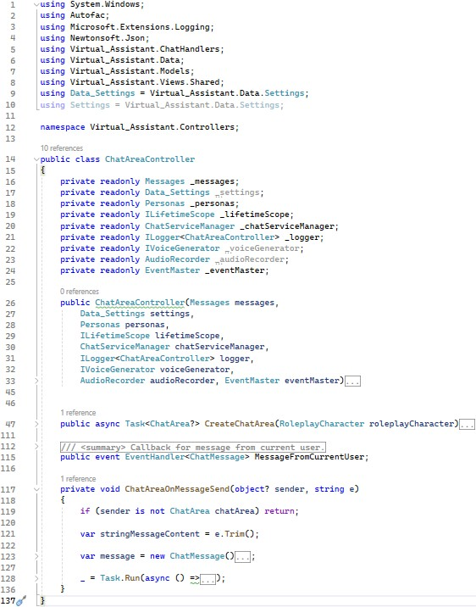
Figure 3.9 – Main controller class ChatAreaController

The Data directory includes elements for managing data, like database context classes, data transfer objects (DTOs), and interfaces to different data sources.
The Migration directory holds database data. Database migration means moving data from one or more source databases to one or more target databases using a migration service. After the migration is done, the data from the source databases is fully transferred, possibly reorganized, to the target databases. Then, client interfaces that used the source databases connect to the new target databases, and the old databases are shut down.
The Model’s directory is part of the application's structure and usually follows the Model-View-Controller (MVC) pattern where the model manages data structure and business logic. This directory holds the application's main logic and data structure. It also has getters and setters for objects needed in the app.
The Resources directory is where non-code assets are stored to improve the user interface and user experience. Font’s directory has custom fonts to keep a consistent style or support multiple languages. Images directory stores icons, buttons, and background images that are important for navigation and user interaction. Colors XAML resource dictionary defines the color scheme, so all parts of the app share the same look.
The "Utilities" folder in the application encapsulates a suite of classes that provide ancillary functions, facilitating common operations across various parts of the application. These utilities aim to abstract and encapsulate specific, often repeated tasks into singular, coherent units of code, thereby enhancing code reusability and maintainability. Let's explore the roles and responsibilities of each class:
Class FileUtilities embodies a collection of methods for asynchronous file operations, likely enhancing performance by leveraging asynchronous I/O to prevent blocking the main thread during file system interactions. Functions within this class can include file copying, deletion, and data streaming, designed for efficiency and minimal resource contention.
Class ProcessUtilities encompasses methods for interacting with system processes. It may include functionality to query, start, or stop processes based on various criteria, such as their directory paths. This class would be integral to ensuring that the application can effectively manage and monitor processes it's associated with, which is particularly relevant for applications that need to track their spawned processes or maintain a clean state by terminating related processes upon exit.
Class StringUtilities provides a toolkit for string manipulation and conversion operations. This utility likely includes methods to sanitize strings by removing or replacing special characters, convert strings to other data formats like bytes, and interface with system-level keyboard input. Additional methods might involve hashing strings for security purposes or formatting keys into user-friendly hotkey strings, suggesting an application that deals with text processing or command parsing frequently.
Class UserControlUtilities focuses on extending the functionalities of user control elements within the application. It can provide methods for retrieving the parent window of a control or fetching a parent of a specific type in the logical tree, indicating a design that supports complex user interface hierarchies. These utilities would be particularly useful for applications with deeply nested UI components or those requiring dynamic UI modifications at runtime.
The "Views" directory serves as a central repository for the graphical user interface (GUI) components of the software application. This collection of Extensible Application Markup Language (XAML) files indicates a design paradigm where the visual aspects of the application are meticulously separated from the business logic, adhering to a model-view-controller (MVC) or similar architectural pattern.
This repository is bifurcated into two primary segments: the "Index" subdirectory, which contain the main interfaces users interact with when performing distinct tasks within the application; and the "Shared" subdirectory, which houses reusable components designed to maintain a consistent user interface across various parts of the application, promoting a uniform user experience. The contents of the "Views" folder encapsulate the aesthetic and functional blueprint of the user's interaction with the application. It is where the abstract functionality of the software is translated into tangible elements that users can interact with, such as buttons, menus, and dialogs. The structure suggests a modular approach, facilitate the scalability of the application, and the potential for reusable components ensures efficiency in development and provides a cohesive visual and operational flow for end-users.
In the desktop development section, we've delved into the technologies and methodologies utilized in crafting our application. This exploration has shed light on the intricacies of integrating artificial intelligence, managing asynchronous operations, and harnessing an event-driven framework, all of which are pivotal for the application's functionality and user experience.
Moving forward, our inquiry will extend to the front-end and back-end development of our website. This phase will involve a thorough evaluation of user interface designs and interaction paradigms, as well as the underlying server-side technologies and database management systems. The objective is to ensure seamless integration and optimal performance across all components of the software ecosystem.

3.2 Web development

The purpose of this section is to break down the complex processes involved in web development into manageable parts, ensuring that developers have a clear path from conceptual design to the actual implementation of both front-end and back-end components. By detailing each stage of the development process, this section helps demystify the intricacies of building web applications that are not only functional but also scalable, maintainable, and secure.

3.2.1 Website Architecture

The website's layout starts with a login page where users need to enter their username and password. After submitting this information, it is checked against the data on the server. If the login is successful, users are smoothly directed to the admin panel. Here, an administrator can control user accounts, including turning them on and off, to make sure only authorized people can access certain features.
The website uses Vue.js to build a Single Page Application (SPA). A single-page application is defined as an application (web app or website) that loads only a single page and then rewrites the page with new content fetched from a web server as the user interacts with it instead of loading a new page for every interaction [36]. This tool helps create a responsive layout that makes it easier for users to interact without waiting long for pages to reload. By keeping information locally, Vue.js reduces server work and improves speed.
The website's design breaks down the user interface into small, reusable Vue components. This modular design makes it easier to build and test. Important parts like the login form, control panel, and user list are designed to be adaptable. Each piece can be changed or swapped without affecting the whole system, speeding up development and making the application easier to maintain and scale.
The website uses Vue-router to move between different parts easily, without refreshing the page. This makes the SPA smoother to use. To protect sensitive areas like the admin panel, Navigation Guards check user login status before showing private sections. This adds a layer of security and ensures only the right users get access.
The website uses Axios to handle data requests between the website and the server's APIs. This tool helps with tasks like user login and managing user data (retrieving, updating, or deleting). This back-and-forth with the API is kept separate from the visible parts of the website. This separation keeps data secure and makes fixing issues easier by keeping backend communication and front-end design separate. This setup improves security and makes development and troubleshooting easier.
The website handles user login on the server. When users log in successfully, the server gives them a session token. This token is crucial for future interactions with the server because it confirms the user's identity and lets them updates data. This way, the website consistently checks the user's login status, improving security and session management.
All data sent between the user's device and the server is protected with HTTPS (Hypertext Transfer Protocol Secure). This encryption keeps third parties from intercepting or tampering with the data while it's sent over the internet, ensuring the information remains safe and private. The project is carefully organized into different folders to make navigation and development easier. Here’s a summary of the main folders and their roles (figure 3.10):

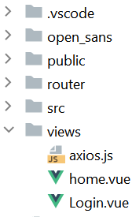
Figure 3.10 – Core directories
The src folder is the heart of the application, holding the Vue.js code that makes everything work. It's where the main code and logic of the application are kept.
The components folder is a vital collection of reusable Vue components. These pieces can be swapped out and used across different parts of the application, saving time and making sure the user interface is consistent.
The router folder manages smooth navigation between components without reloading the page. It has the routing settings for Vue-router, which uses client-side routing. This approach keeps things quick and responsive by reducing waiting times.
The views folder holds Vue components that show the pages. It's important for the modular design since each part focuses on a specific page function, making the application easier to maintain and expand.
The App.vue file is the root component of the website. It brings all other components together, handling the initial page load and updating the site as users interact. It ties everything together and anchors the main features.
The main.js file is the entry point for the website. It starts the Vue instance and sets up key dependencies like Vue-router for navigation and Vuex for managing data. main.js ensures that all libraries and tools are ready from the start.
These folders help keep the code clean and organized while following good software practices like keeping tasks separate, building in pieces, and making testing easier. This structure makes the website solid, easy to manage, and scalable, meeting today's web development standards.

3.2.2 Client-side development

The login.vue file contains the Login Component, which helps users log in to the website [figure 3.11 (see Appendix B)]. This component is a form where users type in their username and password. Its main job is to securely verify their credentials by checking with the server.

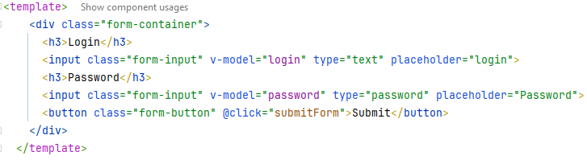
Figure 3.11 – Login Component

When users enter their details, the form captures them and sends the information to the server via an API call. This is done using Axios, a tool that handles communication with the server (figure 3.12).
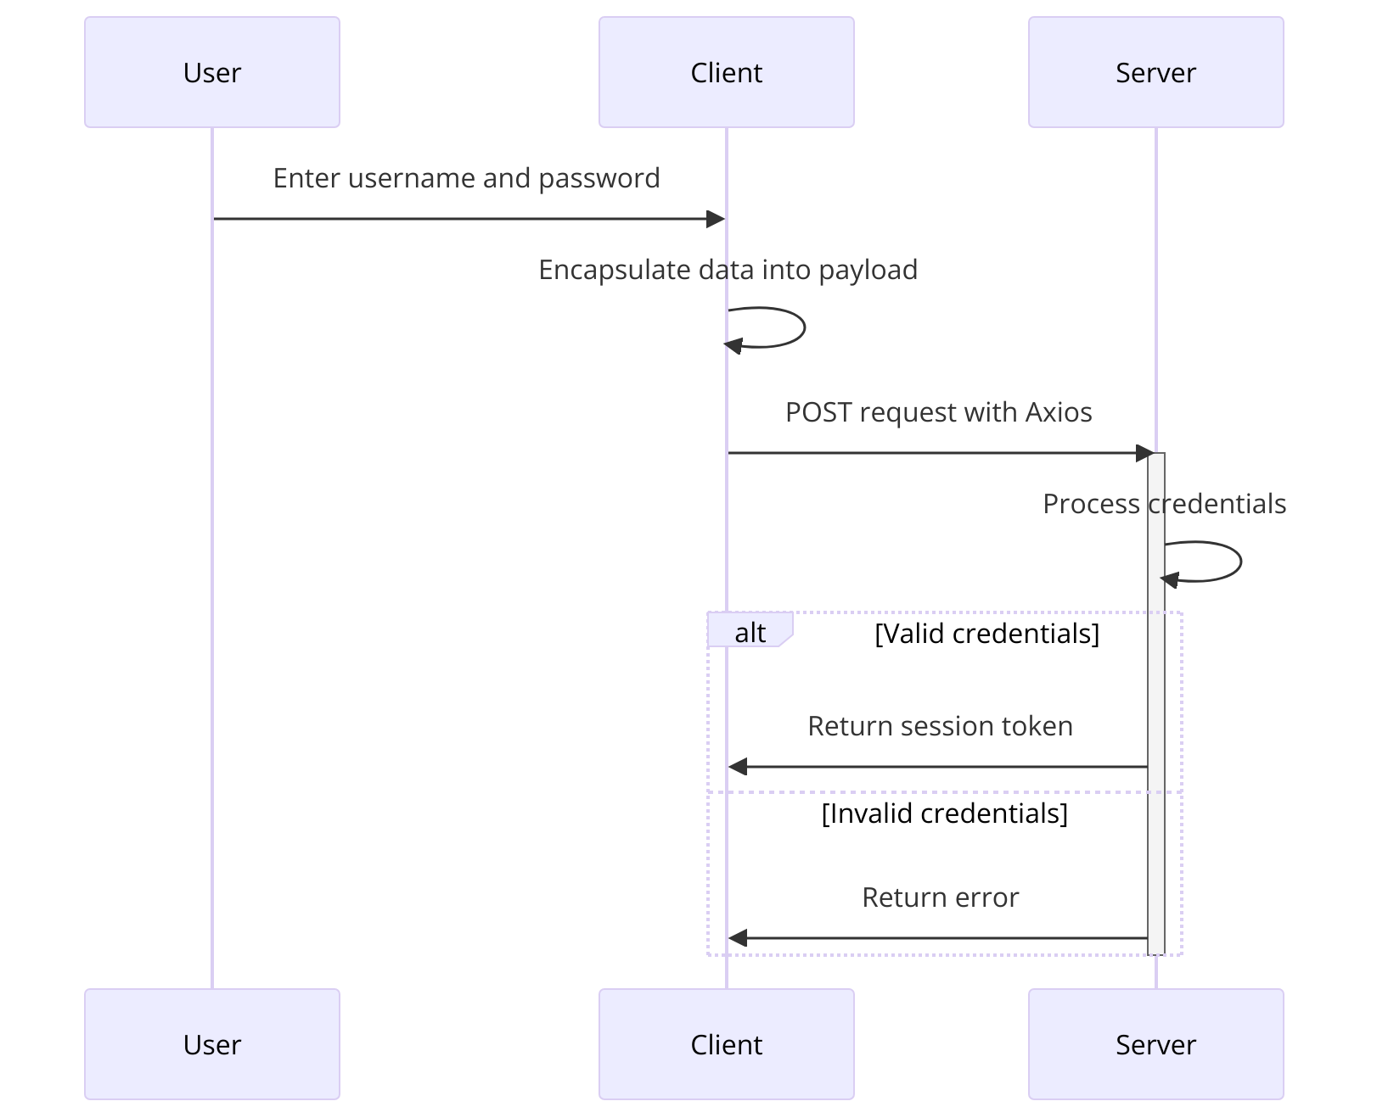
Figure 3.12 – Asynchronous communication with the backend server

The form sends the username and password in a data package through a POST request. Axios manages this request, sending the credentials to the server's login endpoint. The server checks the details and replies. If the credentials are correct, the server usually sends back a session token or confirms success; if not, it sends an error message.
When the server says the login is successful, the user is redirected to the main page of the admin panel. An administration panel should help optimize the team's work and make it more efficient, achieving tasks as fast as possible [37]. This is handled by Vue-router, which changes the page without reloading, keeping the user experience smooth.
This code shows how the component collects user input, sends it to the server, and processes the response to either move forward or show an error message [figure 3.13 (see Appendix B)].
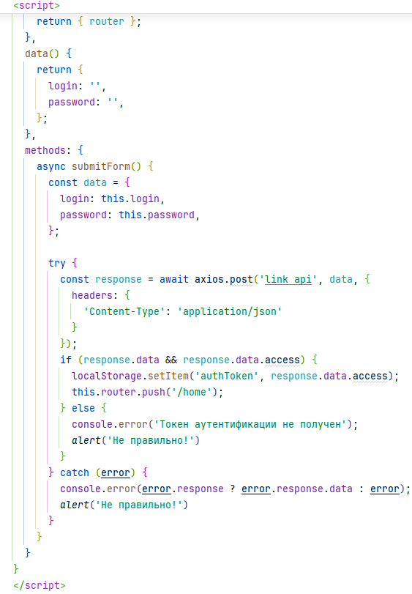
Figure 3.13 – The component handle user input

Vue-router is a key part of Vue.js that helps with web navigation by matching URL paths to components without reloading the page. It keeps the website's state intact, so it behaves like a native app, offering quick transitions and smooth interactions for a better user experience. Vue-router manages the flow of the website by controlling the movement between different pages and sections. It figures out which component to show based on the current URL and manages visibility according to the routing rules in its setup.
In this case, the code sets up a router with two main paths: the root (/) path linked to login.vue and the /home path connected to home.vue [figure 3.14 (see Appendix B)]. Switching between these pages happens without a full-page refresh, giving a seamless and fast user experience.
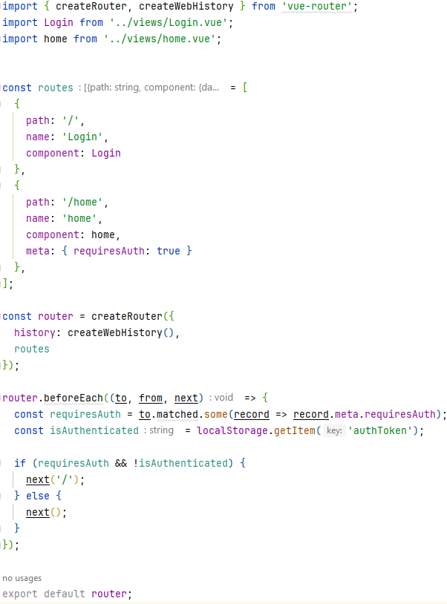
Figure 3.14 – Navigation between pages

Interaction between the front-end and the server is crucial in modern web applications. Axios, a popular JavaScript library for HTTP communication, facilitates this vital connection. Integrated within the components of web applications, Axios handles data transactions with the server, streamlining processes like error handling, data validation, and managing user status. This integration is essential for maintaining a seamless and interactive user experience, ensuring that data flows efficiently between the user interface and the server.

3.2.3 Interaction with the server

Axios, a popular JavaScript library, is widely used for making HTTP requests from web browsers to servers. Its features make it ideal for server interactions in Vue.js applications. HTTP (or HTTPS) is the protocol for the data in the data field of the IP packet [38]. Axios works with promises, which improves how it handles asynchronous requests. This allows the application to deal with server responses effectively, making asynchronous operations run smoothly. It uses interceptors to add authentication tokens to request headers (figure 3.15 (see Appendix B)). This keeps user sessions active and secures communication with the backend. Axios also simplifies error handling with catch blocks, ensuring errors related to network problems or data retrieval are detected and communicated to the user, making the application more reliable.
Furthermore, Axios employs interceptors that enhance request capabilities by automatically appending authentication tokens to headers. This mechanism is crucial for maintaining active user sessions and securing communications with the backend. Additionally, Axios simplifies the management of error handling through its comprehensive use of catch blocks. This setup ensures that errors—whether they arise from network issues or during data retrieval—are promptly detected and communicated to the user, thus enhancing the reliability and robustness of the application.

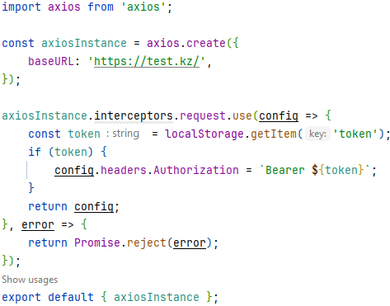
Figure 3.15 – Authentication tokens

The website also utilizes a variety of HTTP request methods to facilitate robust communication with the server. These methods—GET, POST, PUT, and DELETE—each play specific roles within the system, enabling a wide range of interactions from data retrieval to content modification (figure 3.16).
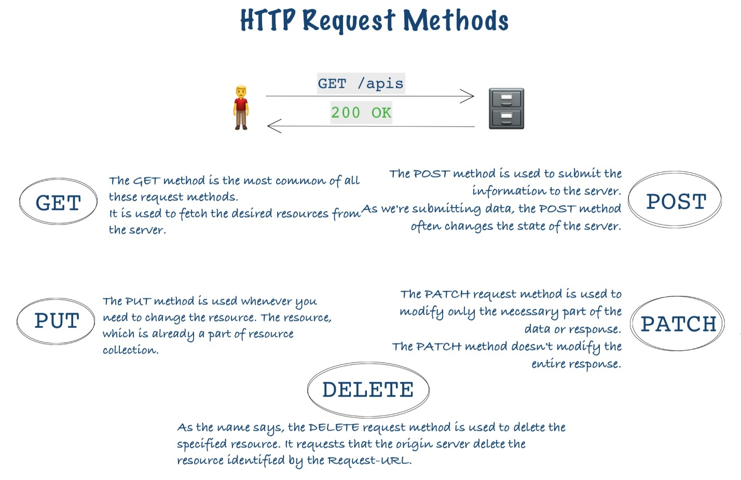
Figure 3.16 – HTTP request methods
HTTP methods such as GET, POST, PUT, and DELETE are crucial in the architecture of web applications, facilitating the creation, reading, updating, and deletion of data—commonly referred to as CRUD operations. The GET method is primarily used to fetch existing data from a server without affecting the data itself, making it ideal for retrieving user profiles or lists of items. POST is used to create new data on the server, such as registering a new user or uploading a file. This method involves sending data through the request body, usually in JSON format. The PUT method is employed to update existing information on the server. For example, it can be used to change a user’s email address or update the quantity of a product in an inventory. Like GET, PUT is idempotent, which means that multiple identical requests will have the same effect as a single request. Finally, the DELETE method removes existing data from the server, effectively deleting user accounts or data entries. These methods are pivotal for developers to interact with web resources efficiently, ensuring that web applications function smoothly and responsively.

4 RESULTS OF THE EXPERIMENT

4.1 Aim of experiment

The main goal of this experiment is to assess how people perceive, prefer, and feel about using AI-based virtual characters in different scenarios. By looking at responses from a wide range of users, the experiment aims to identify the features of virtual characters that are most valued, like understanding natural language, showing emotions, being customizable, and looking good. The experiment also seeks to uncover common challenges and improvement areas to enhance the user experience. This information will help develop more advanced, user-friendly virtual characters that can simulate human interactions and engage users meaningfully in entertainment, education, and support roles.

4.2 User survey about interaction with a virtual character

The survey method involves collecting data from a specific group by asking them a series of questions. Surveys are a method of gathering information from a group of individuals by asking them questions [39]. Surveys are commonly used in research, market analysis, and public opinion studies to understand people's attitudes, opinions, beliefs, and behaviors on a given topic.
Surveys can be conducted through several methods, each with its advantages and disadvantages. Face-to-face interviews, while providing depth and nuance in responses, are time-consuming and costly. Telephone surveys offer a more cost-effective and quicker alternative but often suffer from lower response rates and potential biases in the data collected. Online surveys have gained popularity due to their ability to reach a broad audience quickly and at a low cost. However, they too can face challenges such as biased samples and low engagement rates. Mail-in forms are less common in the digital age but can be useful for reaching demographics with limited internet access. Choosing the right survey research method depends on your objective, timeline, budget, and sample [40].
Surveys are valuable because they give researchers insight into people's attitudes and actions, helping to make decisions in various areas. For example, surveys can measure public opinion about a policy, find out what consumers want from product development, or measure customer satisfaction. In our case, the about AI survey helps us understand user preferences so that we can improve website design and marketing strategies based on user preferences.
According to our survey, 30% of respondents use virtual assistants monthly, showing a growing trend in their use (figure 4.1). However, 25% of people either never use them or only use them weekly, indicating unfamiliarity with this new technology. Interestingly, 20% of people use virtual assistants daily.
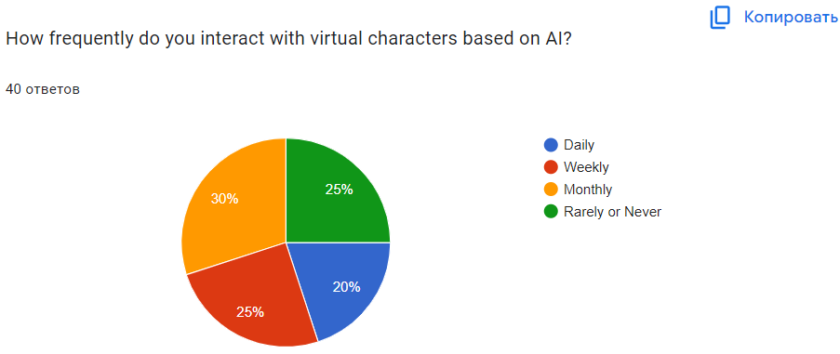
Figure 4.1 – Frequency of virtual assistant use

The survey data reveals why people interact with virtual characters. The largest group, 37.5% of respondents, engages with AI-based virtual characters mainly for entertainment, showing how AI plays a significant role in recreational activities (figure 4.2). Learning is also a big reason, making up 32.5% of responses, which highlights AI's contribution to education and self-improvement. About 30% of participants use virtual characters mainly to help with tasks, proving the practical usefulness of AI in everyday responsibilities. These motivations show how AI-based virtual characters can be used in many ways to meet diverse needs, from entertainment to education and practical help.

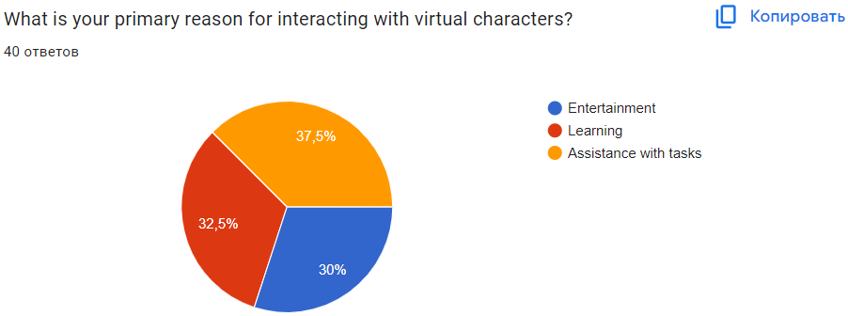
Figure 4.2 – Reason for interacting with virtual characters

The survey also gives insights into how satisfied people are with their current interactions. The largest group, 30%, said they're "somewhat satisfied," meaning that while the interactions meet some expectations, there's room for improvement (figure 4.3). A combined 30% expressed higher satisfaction, with 15% being "very satisfied" and another 15% "neutral," possibly reflecting a balanced view of current virtual character interactions. On the other hand, a noticeable portion of users showed dissatisfaction, with 17.5% "somewhat dissatisfied" and 7.5% "very dissatisfied." This range of satisfaction levels points to varied experiences and expectations with AI, revealing a need for ongoing improvements.
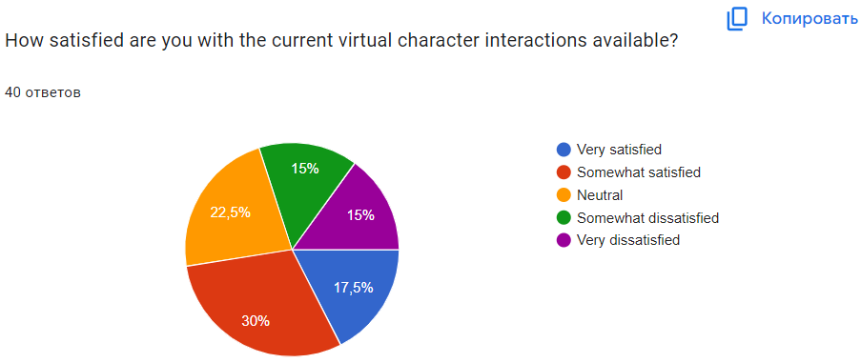
Figure 4.3 – Satisfied with the current virtual character interactions

The survey also sheds light on which virtual character features are most important to users. The top feature, valued by 35% of respondents, is "Natural language understanding," which emphasizes the importance of effective communication between people and AI (figure 4.4). "Emotional intelligence" is the second most valued feature, with 27.5% of users prioritizing the ability of virtual characters to recognize and respond to emotions correctly. "Personalization" is crucial for 20%, showing that people prefer virtual characters that tailor interactions to their preferences. Finally, "Visual appearance" matters to 17.5%, showing how looks play a role in the virtual character experience. This data highlights the different expectations users have, ranging from technical skills to emotional and personalized engagement.

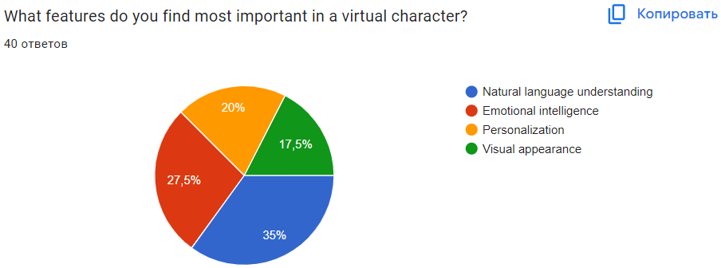
Figure 4.4 – Features in a virtual character

The survey explores the likelihood of respondents recommending a virtual character application to others. A notable 35% of participants are 'Very likely' to recommend it, showing strong support (figure 4.5). Another 30% are 'Likely,' suggesting most users have a positive opinion. However, 20% have some reservations, with 10% 'Neutral' and 10% 'Unlikely.' The remaining 15% are 'Very unlikely,' indicating significant dissatisfaction. Overall, this points to a generally favorable perception of the application, but the concerns of the critical audience could be valuable for improvement.
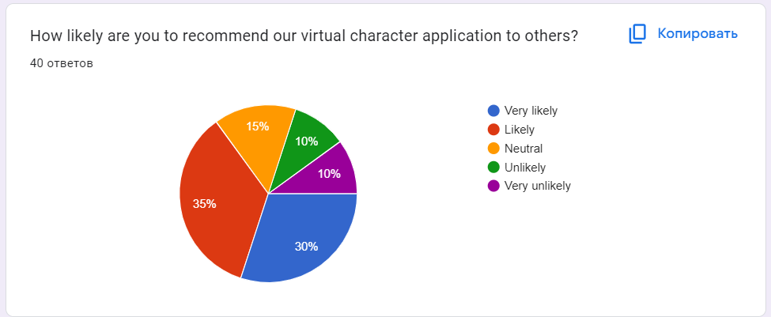
Figure 4.5 – Chance of recommend application

The survey also identifies challenges or frustrations users encounter with virtual characters. The majority (72.5%) haven't faced significant issues, indicating a smooth and satisfactory experience for most users (figure 4.6). However, 27.5% have experienced challenges, highlighting areas that need improvement. That feedback could offer valuable insights into specific aspects that require attention, such as the refinement of AI algorithms to accurately interpret and respond to human emotions.

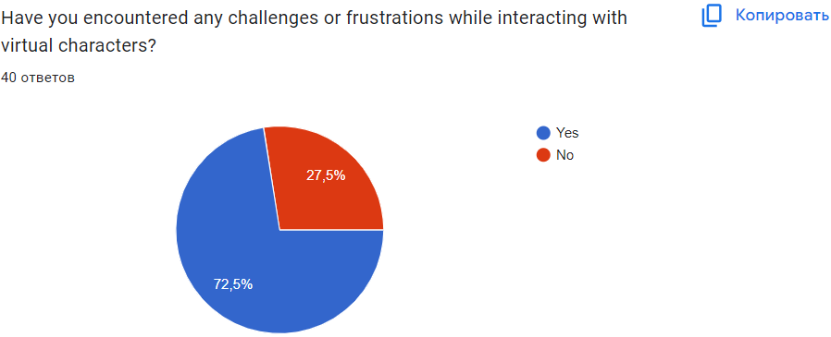
Figure 4.6 – Frustrations while interacting with virtual characters

When assessing comfort levels with virtual characters that mimic human emotions, 25% are 'Very comfortable,' showing high acceptance (figure 4.7). Another 22.5% feel 'Somewhat comfortable,' indicating general acceptance with some reservations. 15% remain neutral, reflecting ambivalence or indifference. However, 22.5% are 'Somewhat uncomfortable,' and 15% are 'Very uncomfortable' with the idea of emotionally adept virtual characters. These responses encapsulate a broad spectrum of viewpoints, reflecting a diverse array of perspectives on the integration of AI-driven emotional capabilities.
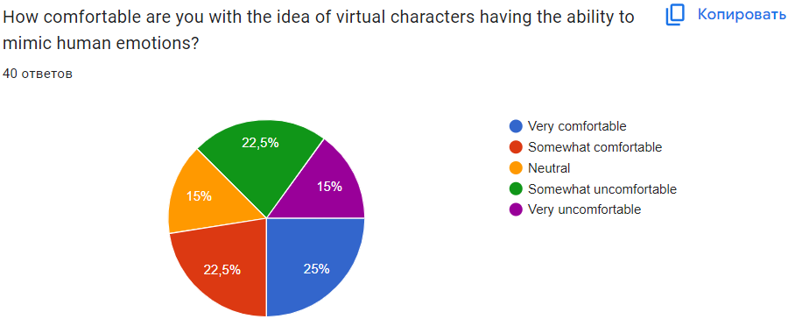
Figure 4.7 – Comfortable if virtual characters having the emotions

The survey provides a nuanced understanding of participants' perspectives on the potential of AI-based virtual characters replacing human interaction. An equal proportion of respondents, each at 35%, believe virtual characters can either "Yes, completely" replace human interaction or "No, not at all," reflecting a significant divide in opinion (figure 4.8). Meanwhile, 30% feel AI characters could "Yes, to some extent" replace human interaction, suggesting that partial substitution may be possible in some contexts. This division underscores the complexity and variability of attitudes toward AI's evolving role in social interactions.

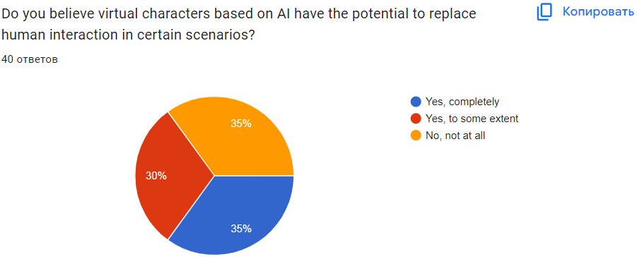
Figure 4.8 – Potential to replace human interaction

The survey highlights respondents' preferences for interacting with virtual characters. The largest segment, at 27.5%, values the "Learning experience," emphasizing AI's educational potential (figure 4.9). Equally important are "Convenience" and "Emotional connection," each at 25%, showing that practicality and forming a bond are equally appealing. "Novelty" appeals to 22.5%, revealing the allure of unique experiences with virtual characters. These insights emphasize the significance of utility and emotional engagement, along with the desire for knowledge and new experiences.
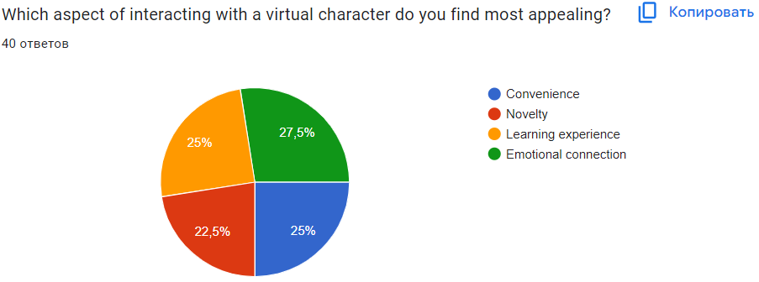
Figure 4.9 – Aspect of interacting

Respondents also shared their views on the importance of virtual characters having distinct personalities. Half the respondents value personality, with 30% rating it "Very important" and 20% considering it "Somewhat important" (figure 4.10). In contrast, 35% expressed less concern, with 20% finding it "Not very important" and 15% saying it's "Not important at all." Meanwhile, 17.5% remain "Neutral." This data indicates that while many prioritize distinctive personalities, others focus on different features.

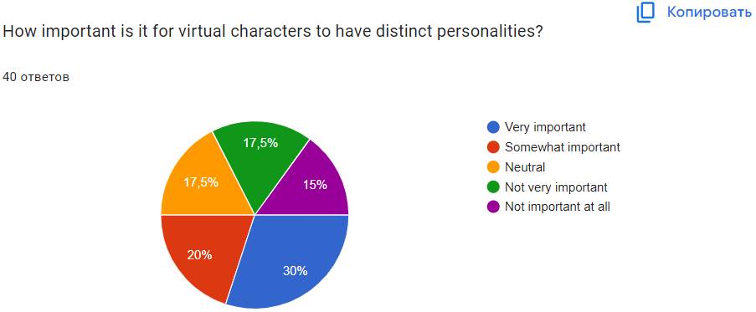
Figure 4.10 – Importance having distinct personalities

When asked about areas where AI-based virtual characters could improve, 30% of respondents cited both "Understanding user intent" and "Providing accurate information" as priorities (figure 4.11). This shows a desire for characters to better comprehend user queries and provide reliable information. Emotional responsiveness is also significant, with 22.5% seeking more emotionally intelligent interactions. Additionally, 17.5% emphasize "Visual representation" as an area for enhancement, indicating demand for more sophisticated visuals. These insights highlight the importance of improving cognitive understanding, emotional intelligence, and aesthetic presentation in virtual characters.
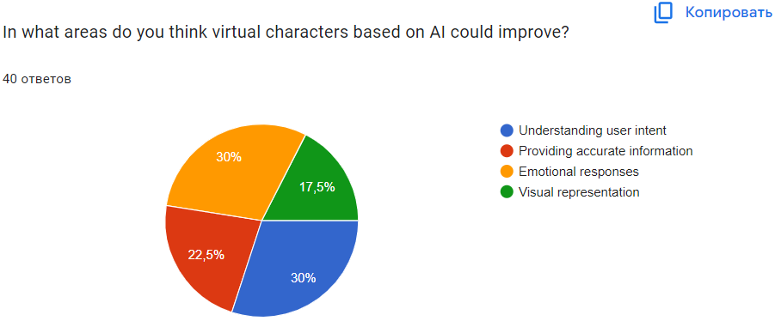
Figure 4.11 – What areas can AI-based virtual characters improve in?

The survey reflects respondents' preferences regarding the personalities of virtual characters, revealing a balanced preference between "Consistent personality" and "Adaptive personality," each favored by 37.5% of participants. This split decision indicates an even division in preferences, with one group valuing the predictability and reliability of a consistent character, while the other appreciates a dynamic approach that tailors’ interactions to individual users. Meanwhile, 25% express "No preference," suggesting that they may value other characteristics equally or find both approaches acceptable. These results reveal diverse user expectations and demonstrate the potential for virtual characters to cater to a range of interaction styles.

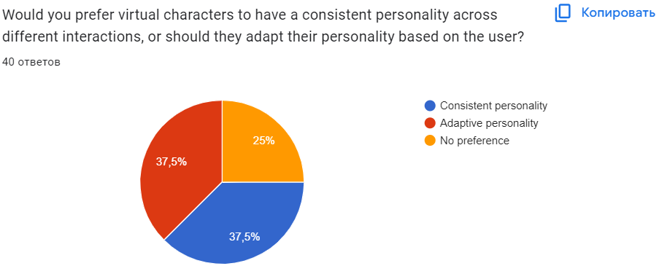
Figure 4.12 – The same personality across different interactions, or should they adapt their personality

In the fourth chapter, the results of the experiment are presented in detail, offering insights into how users interact with AI-based virtual characters. The data, visualized through pie charts, provides an overview of user engagement frequency, motivations, and satisfaction levels. The motivations for using these characters vary from entertainment to assistance, emphasizing the role of advanced natural language processing and emotional intelligence. While satisfaction levels differ, indicating areas for improvement, the research also examines user expectations for virtual character personalities. Findings suggest a preference for a balance between consistent and adaptive character traits, reflecting diverse user needs for stability and personalization in AI interactions.

5 JUSTIFICATION OF ECONOMIC EFFICIENCY

5.1 Technical description

The concept of our project entails the development of a desktop application and website named "AI Character". This application is designed to provide access to artificial intelligence in the form of a virtual character with enhanced functionalities. It enables users to interact with the character through both text and audio interfaces, allowing them to pose questions, request information, or seek assistance in problem-solving.
The target audience for the application encompasses a broad spectrum of users, including students, professionals, researchers, and anyone in need of access to artificial intelligence for information retrieval and task resolution. The application represents an innovative means of communication and assistance, with no direct counterparts currently available in the market.
Key features of the application include:
      - Chat Interface: users can communicate with the character using text and audio interfaces to ask questions or request information.
      - Visual Shell with Animation: the virtual character has an appealing appearance and animated elements that make interactions more engaging and livelier. The animation aids in conveying emotions and expressing various states of the character, enhancing the overall user experience.
      - Natural Language Support: the virtual character has the capability to understand and process natural language, making communication more natural and intuitive.
      - Advanced Functional Capabilities: beyond answering questions, the virtual character can perform various tasks, such as text generation, language translation, list compilation, etc.
      - Content Personalization: the character can tailor its responses to the specific user, considering their preferences and interaction history.
      - Timesaving: the application allows users to quickly obtain necessary information or assistance, saving their time.
      - Multilingual Support: the application supports multiple languages, ensuring accessibility for users worldwide.

5.2 Marketing analysis

Currently, many individuals encounter challenges related to searching for and extracting information. One of the issues is the inefficient interaction with artificial intelligence or the insufficient availability of such technologies. Employees spend approximately three hours per day searching for information necessary for their work, often failing to find it at critical moments. These critical moments are frequent, as each project generates numerous meetings, and each meeting generates notes, action items, and updates—resulting in an ever-increasing accumulation of data that becomes increasingly difficult to locate when it matters most. The consequences of such a deluge of information management are clear yet still distressing: a third of workers report that the inability to find information makes them feel "burned out". Knowledge workers indicate that they spend 58 percent of their day "working for the sake of work".
Our virtual character is designed to address this issue by providing users with access to the advanced capabilities of artificial intelligence through a simple and convenient chat interface. AI has the potential to enhance work efficiency by simplifying tedious tasks such as summarizing meeting records, creating notes and drafts, updating information in databases, etc.

5.3 Marketing plan

According to the website ranking.kz, 88% of Kazakhstan's population use computers, smartphones, and standard software (data from 2021). As per the Kazakhstan Center for Industry and Export, as of January 1, 2022, there were 17,981 active legal entities in the Almaty region, including 17,330 small businesses (96.4%), 529 medium-sized businesses (2.9%), and 122 large enterprises (0.7%). This represents a significant segment that could generate substantial revenue in the future if the application is successfully marketed. Based on the most conservative forecast, the goal is to attract 100 individuals from the population and 5 businesses in the first year.

5.4 Calculation of economic efficiency

At the initial stage, analyzing key economic indicators and calculating the economic efficiency of the project is especially important. This provides an insight into the volume of financial resources needed for project implementation, helps to set the product price, forecast revenues, and allows for the calculation of the project's payback period. In this project, economic efficiency will be evaluated based on the costs of equipment, payment for the labor of developers and maintenance staff, associated overhead expenses, and more.
      - One of the most significant expense items is equipment costs. For the development of this application, the following equipment expenses are required in Table 5.1:

Table 5.1 Equipment costs

№ | Name | quantity | Price (KZT) | Total (KZT)
1 | Laptop Great Asia TK-E140 | 7 | 104990 | 734930
2 | Server hosting | 1 | 30800 | 30800
3 | Website hosting | 1 | 384 | 384
The continuation of Table 5.1

4 | Graphics tablet  HUION H420 | 1 | 10971 | 10971
5 | All | - | - | 777085

The expenses for the necessary equipment amounted to 777,085 KZT.

2. Payroll expenses (wage fund)
The work schedule of the company developing the project follows a standard "five-day workweek" but with some peculiarities. Typically, in the final stages of project development, work proceeds non-stop—without weekends and with hardly any breaks. Entrepreneurs should consider this nuance to adequately compensate dedicated employees in monetary terms.
The list of employees involved in the development of the application and website is presented in the Table 5.2.

Table 5.2 – Personnel

№ | Personnel | Working period (months) | Number of people | Salary | Total
1 | Project manager (PM) | 1 | 1 | 250000 | 250000
2 | Frontend developer | 1 | 1 | 300000 | 300000
3 | Backend developer | 1 | 1 | 400000 | 400000
4 | C# developer | 1 | 1 | 450000 | 450000
5 | QA engineer | 1 | 1 | 150000 | 150000
6 | Graphic 3D designer | 1 | 1 | 200000 | 200000
7 | Marketer | 1 | 1 | 300000 | 300000
8 | UI/UX designer | 1 | 1 | 200000 | 200000
9 | Technical Support Specialist | 1 | 1 | 250000 | 250000
10 | All | - | - | - | 2500000

Consequently, the salary fund amounted to 2,500,000 KZT.
Next, it is necessary to calculate the amount of mandatory contributions from the payroll, which includes social contributions, social tax, and mandatory social medical insurance (ОСМС in Kazakh context).
Social contributions = 3.5% * (Gross Salary - pension contributions) = 0.035 * (2,500,000 - 2,500,000 * 0.1) = 78,750 KZT
Contributions to ОСМС = 3.5% * Gross Salary = 0.035 * 2,500,000 = 87,500 KZT.
Social tax = 9.5% * (Gross Salary - pension contributions - employee medical insurance contributions) - social contributions = 0.095 * (2,500,000 - 2,500,000 * 0.1 - 87,500) - 78,750 = 126,687.5 KZT.
Thus, the total mandatory contributions from the overall payroll of all employees = 78,750 + 87,500 + 126,687.5 = 292,937.5 KZT.
Therefore, the labor cost will be:
Total payroll + contributions = 2,500,000 + 292,937.5 = 2,792,937.5 KZT.

3. Overhead Expenses.
Overhead expenses are costs not directly related to the development of the application. In our case, these include rent for premises, payment for utilities, and internet which are shown in the Table 5.3.

Table 5.3 - Overhead Expenses:

№ | Name | Quantity | Price, KZT | Total price, KZT
1 | Renting premises | 150 sq.m. | 5000 | 750000
2 | Electricity | 250 kWh | 25,94  VAT included | 6485
3 | Internet Wi-Fi JSC Kazakhtelecom | Minimum package | 3999 | 3999
4 | Total | - | - | 760484

Given the absence of auxiliary staff and the need for office supplies, we have calculated the overhead expenses as described above, amounting to 760,484 KZT.

4. The total costs for the development of the application and website amounted to:
equipment costs + labor cost + overhead expenses = 777,085 + 2,792,937.5 + 760,484 = 4,330,506.5 KZT.

5. Based on the marketing plan, let's assume that at the initial stage, we will have an average of 100 downloads per month. The development and initial promotion of the application will take an average of 4 months (development – 1 month, promotion – 3 months). Thus, over the following 8 months, we will have 100*8 = 800 downloads. On average, one download costs 1.5–2 dollars, or approximately 890 KZT. Therefore, over 8 months, we will have an income from downloads = 800*890 = 712,000 KZT. To purchase a Premium subscription, a user will also need to pay $5.9 per month or approximately 2,600 KZT per month. If only 8 of attracted users will purchase a subscription at the initial stage, over 8 months, we will earn an income from subscriptions amounting to 8*2600*8 = 166,400 KZT.
In addition, assume that 5 organizations per year will be interested in this application. We'll set the price of the application with installation and synchronization at 100,000 KZT. From 5 organizations - the income will be 500,000 KZT.
Thus, the income in the first year will amount to 712,000 KZT + 166,400 KZT + 500,000 = 1,378,400 KZT.
The absolute economic efficiency of the project for the first year is calculated as profit/costs = (1,378,400 - 4,330,506.5) / 4,330,506.5 = -0.68, where profit equals income minus costs, i.e., 1,378,400 - 4,330,506.5 = -2,952,106.5. This means the project's efficiency is null in the first year. For the first year, where maximum expenditures are required, this is entirely acceptable. For the second year, with an increase in the rate of user attraction to 500 people per month, we have the following economic efficiency:
500 * 12 * 890 = 5,340,000 KZT
60 purchased subscriptions * 2,600 * 12 = 1,872,000 KZT
5 organizations * 100,000 KZT = 500,000 KZT
Total income = 5,340,000 + 1,872,000 + 500,000 = 7,712,000 KZT.
The costs can be determined as the salary of one administrator (technical support) at 250,000 KZT equaling 279,293.75 KZT with all contributions included. Purchasing equipment and hiring staff for app development will no longer be required.
For the second year, profit/costs = (7,712,000 - 279,293.75) / 279,293.75 = 26.6 (profit = income - costs, i.e., 7,712,000 - 279,293.75 = 7,432,706.25).
The absolute economic efficiency over two years amounts to (9,090,400 - 4,609,800.25) / 4,609,800.25 = 0,97.
Payback period = initial investment sum / average annual cash flow.
The average annual profit = (-2,952,106.5 + 7,432,706.25) / 2 = 2240299,875 KZT
Payback period = 4,330,506.5 / 2240299,875 = 1,93 years (1 year and 11 months).
Therefore, the economic efficiency analysis indicates that in developing the "AI Character" application, with development costs of 4,330,506.5 KZT, the first year will incur a loss of -2,952,106.5 KZT, and the following year, the annual profit will be 7,432,706.25 KZT. With an economic efficiency of 0,97 over two years, the project pays off in 1,93 years (1 year and 11 months). Hence, it can be concluded that the proposed project is economically inefficient in the first year but will significantly increase in efficiency in subsequent years with the further expansion of the user base.
The economic efficiency and payback period shown above are calculated from the perspective of justifying the project's profitability for the application developer.

5.5 Calculation of the effectiveness of software implementation for an enterprise

Based on the calculations, we determined that the development of the software (ПП) costs us 8,413,018.75 KZT.
We have set the selling price of this product at 500,000 KZT.
Let's calculate the economic efficiency of implementing this software in the organization's operations.
The economic efficiency is calculated based on both direct and indirect effects. In our case, it is possible to calculate the economic efficiency by reducing the labor costs of the staff involved when using this software.
The following formulas are used to calculate economic efficiency:
- Absolute reduction in labor costs (ΔT):

ΔТ=Т0 - Т1 (1)

where Т0 is the labor costs for information processing with existing equipment;
Т1 is the labor costs for information processing with the new equipment;
- Coefficient of relative reduction in labor costs (КТ):

КТ =ΔТ/T0 (2)

- Index of labor cost reduction or labor productivity increase due to the use of new equipment (YT):

YT=T0 /T1 (3)

Table 5.4 - Calculations of economic efficiency through labor cost reduction

№ | Stages of work | Т0 | T1 | ΔT | КТ | YT
1 | Updating information in the database | 15 min | 5 min | 10 min | 0,6 | 3
2 | Customer communication and support | 10 min | 5 min | 5 min | 0,5 | 2
3 | Search for information | 5 min | 1 min | 4 min | 0,8 | 5
4 | Summary of the entire scope of work | 30 min | 11 min | 19 min | 0,63 | 2,7

The calculations indicate a 63% reduction in labor efforts. This decrease suggests a reduction in the workload for handling calls and inquiries due to increased automation and improved service quality, affirming the efficiency of implementing this software solution.
Let's calculate the cost savings in monetary terms by comparing the cost of work using traditional technical support versus the proposed software solution, through determining the economic effect, i.e., by comparing the cost savings due to an absolute reduction in costs.
Economic effect = cost before implementation - cost after implementation. (4)

Table 5.5 - Calculation of the economic effect of implementing the proposed software over a year

№ | Cost of work | Before implementation | After implementation
1 | PP cost | 0 | 500000 tenge
2 | Payroll of technical support staff | With a salary of 250,000 tenge per month * 1 technical support employee * 12 months = 3,000,000 tenge (including taxes = 3,292,937.5 tenge per year) | 3292937.5–3292937.5*0.63= 1218386.875 tenge
3 | Payroll system administrator | With a salary of 200,000 tenge per month * 12 months = 2,400,000 tenge (including taxes = 2,692,937.5 tenge per year) | 2692937.5–2692937.5*0.63= 996386.875 tenge
4 | Total | 5985875 tenge (3292937.5 tenge + 2692937.5 tenge per year) | 2714773.75 tenge (500000 tenge + 1218386.875 tenge + 996386.875 tenge)
5 | Economic effect (formula 4) | 3271101.25 tenge (5985875 tenge - 2714773.75 tenge)

Now, let's calculate the payback period for implementing this software in the company's operations:
Payback period = initial costs / cost savings
Payback period = 2714773.75 KZT / 3271101.25 KZT = 0.82 years,
which is equivalent to 10 months.
Therefore, by acquiring the software product developed in the project, with total expenses of 2714773.75 KZT, the organization will reduce labor efforts by 63% and recoup these investments within 0.82 years, i.e., within 10 months, and achieve an economic effect in savings of 3271101.25 KZT. This demonstrates the profitability of acquiring and implementing the developed product into its operations.

CONCLUSION

The objective of this diploma work was to design and implement an AI-enhanced website and application for a virtual character, tailored to meet the expectations of the intended audience and to facilitate effective interaction with the virtual entity. This work was structured into five distinct chapters, each dedicated to a specific aspect of the development process.
The first chapter undertook a comprehensive review of existing applications and websites that utilize similar technologies. This analysis provided an overview of the current market offerings, elucidated the demand and utility of virtual characters, and conducted a global and local (Kazakhstan) comparative study of similar technologies. The findings from this review enabled the identification of strengths and weaknesses in the current market, guiding the selection of the most appropriate development tools for our platform.
The second chapter delineated the theoretical framework underpinning the project, focusing on the design and planning phases of the website. It commenced with the establishment of functional requirements, followed by detailed descriptions of the design methodologies employed, including use case diagrams, entity-relationship (ER) diagrams, Unified Modeling Language (UML) diagrams, and microservices architecture.
The third chapter detailed the practical implementation of the application and website, building on the theoretical foundations laid in the previous chapter. This segment of the thesis began with the application development and subsequently discussed the website construction processes.
In the fourth chapter, the outcomes of an experimental study designed to assess user engagement with the AI-powered virtual characters are presented. The findings revealed nuanced insights into the frequency of user engagement with virtual characters, the primary motivations for such interactions, and the overall satisfaction with the current state of virtual character technology.
The fifth chapter provided an economic assessment of the project, presenting a technical overview, market analysis, marketing strategy, and a cost-effectiveness evaluation. The analysis confirmed that the website and application deployment would yield a positive economic impact for the organization.
In conclusion, this diploma work successfully fulfilled its aim of developing a website and application that not only meets the requirements of its target users but also enhances the management of virtual interactions. This endeavor contributed to the existing body of knowledge in the domain of virtual character engagement and yielded practical insights into the architectural and operational intricacies of substantial software projects. The experimental results affirmed high user satisfaction regarding the platform's usability and design, while the economic justification underscored the prospective financial benefits. The project's success can be attributed to an exhaustive evaluation of existing solutions, adept selection of development tools, and a strong emphasis on user-centric design.

REFERENCES

- West, D. M., & Allen, J. R. (2018). How artificial intelligence is transforming the world.
- Shyam Sundar, S. (2020). Rise of Machine Agency: A Framework for Studying the Psychology of Human–AI Interaction (HAII). Journal of Computer-Mediated Communication, vol. 25, no. 1, pp. 74–88.
- Handini, B. S., Panly, F. I., & Nurhasanah. (2022). The Effect of Artificial Intelligent Technology Used (Duolingo Application) To Enhance English Learning, pp. 81-89.
- Brandtzaeg, P. B., Skjuve, M., & Følstad, A. (2022). My AI Friend: How Users of a Social Chatbot Understand Their Human–AI Friendship. Human Communication Research, vol. 48, no. 3, pp. 404–429.
- Brachet, L. (2023). What Is Nova AI chatbot? A detailed Overview.
- HTML basics – learn web development: MDN Learn web development | MDN, [Online]. Available: https://inlnk.ru/4yjOw0 (Accessed: September 2023).
- Duckett, J. (2011). HTML & CSS Design and Build Websites.
- Ellow Talent. (2023). Advantages and Disadvantages of HTML. [Online]. Available: https://inlnk.ru/emd4N2 (Accessed: September 2023).
- CSS: Cascading Style Sheets| MDN web docs, [Online]. Available: https://inlnk.ru/G6zOeg (Accessed: September 2023).
- Raj, A. (2023). Advantages and Disadvantages of CSS (Cascading Style Sheets). [Online]. Available: https://inlnk.ru/w4n8mD (Accessed: October 2023).
- Anam, R. (2023). Free Resources for Web Developers: Unleashing the Power of Knowledge.
- Haverbeke, M. (2024). Eloquent JavaScript, pp. 330-371, 4th ed.
- Introduction to Node.js | Node.js official documentation, [Online]. Available: https://inlnk.ru/20vOd9 (Accessed: October 2023).
- Introduction to Vue.js | Vue.js official documentation, [Online]. Available: https://inlnk.ru/KezO3P (Accessed: September 2023).
- About npm | npm official documentation, [Online]. Available: https://inlnk.ru/3ZROXK (Accessed: October 2023).
- Promise based HTTP client for the browser and node.js | Axios official documentation, [Online]. Available: https://inlnk.ru/BpzOQZ (Accessed: November 2023).
- Introduction to NET | .Net official documentation, [Online]. Available: https://inlnk.ru/57YOzv (Accessed: November 2023).
- Puppeteer-sharp Documentation, [Online]. Available: https://inlnk.ru/ag84MO (Accessed: November 2023).
- Introduction to Visual Studio | Visual Studio official documentation, [Online]. Available: http://surl.li/tritu (Accessed: December 2023).
- Git and GitHub Introduction, [Online]. Available: http://surl.li/trisy (Accessed: December 2023).
- Introduction to Notion | Notion official documentation, [Online]. Available: http://surl.li/tritd (Accessed: December 2023).
- Introduction to Elevenlabs | Elevenlabs official documentation, [Online]. Available: http://surl.li/tritf (Accessed: January 2024).
- Introduction to VTube Studio | VTube Studio official documentation, [Online]. Available: http://surl.li/trisr (Accessed: January 2024).
- Introduction to Blender | Blender official documentation, [Online]. Available: http://surl.li/trisg (Accessed: January 2024).
- Postman – Introduction | Tutorialspoint, [Online]. Available: http://surl.li/trirr (Accessed: February 2024).
- Introduction to Postman | Postman official documentation, [Online]. Available: http://surl.li/trisa (Accessed: February 2024).
- Demir, D. (2023). What is Postman (A Tutorial for Beginners), pp. 30-45.
- Hossain, M. I. (2023). Software Development Life Cycle (SDLC) Methodologies for Information Systems Project Management, pp. 2-15.
- Jain, A. (2023). What Are The 7 Phases of Website Development, [Online]. Available: http://surl.li/triqt (Accessed: February 2024).
- Practical Logix (2024). Crafting Excellence: The Art and Science of Application Design and Development, [Online]. Available: http://surl.li/triqo (Accessed: March 2024).
- Brush, K. (2020). What is a use case, [Online]. Available: http://surl.li/trirg (Accessed: March 2024).
- Zanini, A. (2023). ER Model, ER Diagram, and Relational Schema: What's the Difference, [Online]. Available: http://surl.li/trira (Accessed: March 2024).
- Kaněra, M. (2023). UML Class Diagrams: All you need to know, [Online]. Available: http://surl.li/trirl (Accessed: April 2024).
- Salaheddin, N., & Ahmed, N. A. S. (2022). Microservices vs. Monolithic architectures, [Online]. Available: http://surl.li/gclom (Accessed: April 2024).
- Geeksforgeeks.com (2023). Difference Between Process, Parent Process, and Child Process, [Online]. Available: http://surl.li/triqw (Accessed: April 2024).
- BasuMallick, C. (2022). What Is a Single-Page Application? Architecture, Benefits, and Challenges, [Online]. Available: http://surl.li/trnxl (Accessed: May 2024).
- Paderina, A. (2021). How to Create a Good Admin Panel: Design Tips and Features List, [Online]. Available: http://surl.li/trnza (Accessed: May 2024).
- Hypertext Transfer Protocol (HTTP), Google Classroom, [Online]. Available: https://clck.ru/3AeMn6 (Accessed: May 2024).
- Bhat, A. (2022). Surveys: What They Are, Characteristics & Examples, [Online]. Available: https://clck.ru/3AeN5X (Accessed: May 2024).
- William, K. (2024). 9 Types of Survey Methods and How They Work, [Online]. Available: https://clck.ru/3AeQBG (Accessed: May 2024).

APPENDIX A

Figure 1 – Use Case
Figure 2 – ER diagram
Figure 3 – UML diagram
Figure 4 – Monolith architecture

APPENDIX B

Figure 5 – Class CharacterAiClient
Figure 6 – Сlass PuppeteerLib

Figure 7 – Сlass common in namespace SharedUtils
Figure 8 – Сlass CoreVTSPlugin in namespace VTS.core
Figure 9 – Сlass CharacterAiChatHandler

Figure 10 – Main controller class ChatAreaController

Figure 11 – The component handle user input

Figure 12 – Navigation between pages

